A COGNITIVE COMPUTING ARCHITECTURE

A Dissertation Presented
By
John E. Lecky
To
The Faculty of the Graduate College
of
The University of Vermont

In Partial Fulfillment of the Requirements
For the Degree of Doctor of Philosophy
Specializing in Electrical Engineering

December, 1998

Accepted by the Faculty of the Graduate College, The University of Vermont, in partial fulfillment of the requirements for the degree of Doctor of Philosophy specializing in Electrical Engineering.

Dissertation Examination Committee:

______________________________ Advisor
Richard G. Absher, Ph.D.

______________________________ Chairperson
Guo-Liang Xue, Ph.D.

______________________________
Ronald W. Williams, Ph.D.

______________________________
Peter Fuhr, Ph.D.

______________________________ Interim Dean, Graduate College
Andrew R. Bodman, Ph.D.

Date: December 23, 1998

Abstract
This describes a new computer hardware architecture that complements existing computer architectures by making difficult decision problems, such as problems which are NP-complete, easy to solve.
A description of the kinds of problems that are difficult to solve with present-day electronic computers is contrasted and coupled with a broad overview of the anatomy of the human brain. A model for how the brain might solve these problems is proposed, and then a new computer hardware architecture, called scouting, is developed which operates based on this model.
Scouting, at its foundations, is a simultaneous forward simulation technique in which many simple independent processors search for solutions in parallel. In the biological analogy, each of these processors would be a group of 100 to 2000 neurons, and 10,000 or more processors would be assumed to exist. This biological model derives from the anatomy of cortical macrocolumns.
Scouting simulations are performed on a variety of problems that are challenging to solve using standard “artificial intelligence” computer programming techniques. Scouting performance compares very favorably with these traditional computer methods. Two simulated problems, Garage Door and Stream Crossing, are extracted from real-world daily living situations to illustrate the generality of the technique.
A theoretical basis for scouting is developed from statistics and combinatorics. Several mathematical results are used to provide an accurate estimation of the accuracy and parallel run time of scouting in the solution of any puzzle or problem requiring sequences of decisions.
A set of new research areas is proposed, demonstrating the fundamental and broad applicability of the new architecture.

Table of Contents
1 Introduction 1
1.1 Overview 2
2 Related Topics in Computer Science 5
2.1 Algorithms 5
2.2 Algorithmic Complexity 6
2.3 P and NP 7
2.4 NP-completeness 8
2.5 Solving NP-complete Problems 9
2.6 Thinking Algorithmically; 8 and 15 Puzzles 10
2.7 Thinking: The Garage Door Problem 13
2.8 Generalization to Games 15
2.9 Evaluating Thinking Machines Using Puzzles and Games 16
2.10 A Learning Model for Puzzles and Games 17
2.10.1 Situation 18
2.10.2 Rules 18
2.10.3 Goal 18
2.11 Neural Network Research 19
3 Neuroanatomy and Neurophysiology : A Brief Tour 21
3.1 The Neuron 21
3.1.1 Neuron Summary 25
3.2 The Brain 25
3.3 Brain Signal Input Conditioning 39
4 A Model for Brain Operation 43
4.1 Cortex and Downtown as the Computing Machine 44
4.2 Memory Divided in a Procedural/Declarative Arrangement 47
4.3 Size is REALLY important 47
4.4 Data Storage and Data Processing are Separate 48
4.5 Many general-purpose CPUs give the most flexible design 49
4.6 Wiring dictates behavior 50
4.7 The Constant Drive of Evolutionary Goals 50
5 A Computing Architecture 52
5.1 The Wanderer 54
5.1.1 8-Puzzle Wanderer Simulation 55
5.2 Scout 58
5.2.1 8-Puzzle Scout Simulation 59
5.3 Scout Hardware Implementation 60
6 A Theoretical Analysis of Scouting Efficiency 62
6.1 Coverage Analysis 63
7 Using Scouting to Solve Other Problems 70
7.1 Stream Crossing 71
7.2 Missionaries and Cannibals 72
7.3 The 15-Puzzle 72
8 Looking Forward 74
8.1 How Does Scouting Relate to Associative Memory 74
8.2 Does the Scout Follow Neuroanatomy? 75
8.3 A Complete Thinking Machine 76
8.4 Duplicate the Brain, or Surpass It? 78
8.5 Implementing Learning 78
8.6 Learning Procedural Models 80
9 Conclusions 82
10 Appendix A: Wanderer Simulation 83
11 Appendix B: Scout Simulation 86
12 Bibliography 87

List of Figures
Figure 1: 8-Puzzle Search Tree, first three moves 11
Figure 2: The Garage Door Problem 14
Figure 3: Synthesizing Strategy 18
Figure 4: Respective Sizes of Mammalian Brains 27
Figure 5: A Brain in Three Parts 28
Figure 6: A Brain In Five Parts 28
Figure 7: A More Complete Brain Schematic 29
Figure 8: Brain Structure 31
Figure 9: More Detailed Cortical Map 32
Figure 10: Some Intemediate Cortical Detail 33
Figure 11: Thalamic Input Preprocessing 35
Figure 12: Internal Brain Wiring Pathways 36
Figure 13: Neocortex Explosion in Humans 37
Figure 14: Downtown Brain 38
Figure 15: Optical Routing via LGN 40
Figure 16: Detailed Map of LGN Interconnection 41
Figure 17: Approximate Visual Filter Bank 42
Figure 18: The Wanderer 54
Figure 19: The Scout 58
Figure 20: Scout Hardware Block Diagram 61
Figure 21: Scout Neural Model 75
Figure 22: Comprehensive Brain Processing Model 77

List of Tables
Table 1: Wanderer Results 56
Table 2: Scout Results 59
Table 3: Coverage Capability with Various Puzzles 70

Introduction
For as long as there have been humans on Earth, there have been discussions on the nature of intelligence. For as long as there have been electronic computers, there have been discussions on whether human-like intelligence might be built into a machine. Modern computer technology seems as though it should provide all of the components necessary for the construction of intelligent machines. Nevertheless, the realization of any machine with even remotely human intelligence continues to appear far off.
The failures of current electronic computer technology in replicating human intelligence are most obvious in the following three areas.
- Memory. Computer memory strategies start with an address. We must know where something is stored to retrieve it. Human memory strategies require only some set of properties or hints to trigger lookup. Location of storage is abstract and immaterial.
- Thinking. Thinking is the generation of new information from old. Computers require algorithms to do this, but the existence of an algorithm implies that all of the thinking has already been done. What is the strategy when the algorithm is unknown, or no algorithm exists?
- Massive Parallelism. A fly has 1 million neurons. A human has 10 billion. The obvious disparity in intellect between flies and humans suggests that there is something very important about computing with billions, not millions, of processing elements. Most parallel computing systems available today have at most thousands of processors.
This dissertation describes a practical, digital computing hardware architecture capable of “cognition,” which can be described as the use of knowledge to solve problems.
The design proposed relies heavily on a biological model for analytical thought that involves the use of many individual processors; these individual processors are not to be thought of as biological neurons, but rather as clusters of 100-2000 biological neurons arranged as macrocells. This digital model may or may not be an accurate representation of the true operation of biological cognitive hardware; in either case, the correctness of the biological model is not a requirement for the usefulness of the digital version. As will be seen, however, there is strong anatomical and physiological support for the architecture proposed herein.
A major obstacle to understanding and organizing the material to follow is the lack of knowledge regarding what pieces of the biological design are critical and immutable. Much as Orville and Wilbur Wright were able to advance powered flight much more rapidly once they realized that feathers and flapping wings were not required, this research requires that many details be ignored in order to develop a realizable design. The key is in choosing which biological elements to retain, and which to ignore. This, if anything, is the fundamental challenge undertaken in what follows.

Overview
The goal of this dissertation is to describe a machine capable of analyzing and solving arbitrary, complex problems very quickly. Primarily, this focus will examine a new way to think about applying many processors to difficult problems.
The architecture is intended to be general purpose; that is, it is equally comfortable and effective solving toy puzzles, playing checkers, analyzing speech, or figuring out the best way to get across a stream by stepping on dry rocks.
The general-purpose nature of the machine requires that it not use carefully-crafted “heuristics” or “knowledge-bases” to solve a new problem. The system must be capable of synthesizing solutions directly from nothing but a knowledge of the problem, what the allowable actions are in solving it, and what is the desired outcome. These characteristics of a problem can be called Situation, Rules, and Goal, and we will see that any problem, puzzle, or game, synthetic or real-world, may be described in these terms.
Early on, it was realized that an obvious way to construct such a general-purpose machine that did not require special “programming” to solve a new problem was to build an exhaustive search machine. Exhaustive search involves simulating every possible outcome based on every possible sequence of actions. Exhaustive search, or “brute-force” computing, has typically only been effective for the simplest of problems.
Several factors suggest that a re-examination of exhaustive-search-based computing is timely. First, the continued explosion of digital computing power means that many problems unsolvable with brute-force techniques just a few years ago may now be directly solved through the application of more computing horsepower.
A second, more compelling reason to reinvestigate exhaustive search, is the continued revelation of architectural details in the animal brain. Most animals, especially humans, are capable of solving a variety of problems that digital computers still have a very difficult time with. Further, the learning capability of animal brains is entirely unduplicated in electronic computer architecture, since electronic computers require explicit programming on a per-problem basis, making learning seem a daunting task.
The most interesting development in our understanding of brain architecture is that a large number of relatively small and very similar processing circuits seem to be responsible for problem solving in all areas, including logic, reasoning, speech recognition, speech synthesis, vision, and motion control. In humans, for example, a network of about 10⁶ cylindrical processors, each made up of 2000 neurons or so, comprise the outer covering of the brain, known as the cortex, which is responsible for most of the sophisticated processing upon which we humans pride ourselves so much. In the sections to follow, proposals will be made regarding how these processors might be tasked to “create” intelligence.
Chapters 2 and 3 will develop background material from computer science and neurobiology. This information is critical to the development of the cognitive and computing models that follows in Chapter 4.
Chapter 5 describes the new computing architecture, and is followed by a mathematical effectiveness analysis in Chapter 6.
Chapter 7 scratches the surface of how to generalize the computing architecture to solve a variety of unrelated problems, and Chapter 8 proposes future research topics.
Conclusions are presented in Chapter 9.

Related Topics in Computer Science
This section motivates the development of an alternate computer architecture specifically designed to solve problems that current computers find “intractable.”

Algorithms
Most early texts on computer science define the term algorithm in a way similar to the following:
An algorithm can be defined as a sequential procedure consisting of a finite number of unambiguous instructions or actions working on some initial data or information and producing some final result.
Robert Sedgewick, a well-published authority on algorithms, has more recently put forth a quite different definition:
The term algorithm is used in computer science to describe a problem-solving method suitable for implementation as computer programs.
This second definition is probably much more accurate (although less correct from a theoretical standpoint). The implication of this definition is that the acceptability of a problem-solving strategy depends upon the computing equipment it is intended to run on.
Algorithms must be made up of deterministic steps. By deterministic is meant that the next operation of the algorithm is completely specified by its current operation. This ties into the “unambiguous operations” notion of the first definition of algorithm, requiring that no “guessing” or “miraculous” steps are required. An example of a nondeterministic step would be:
Step 1: Choose the largest prime number evenly divisible into an input value
The reason that this is a nondeterministic step is that the operation of factoring a number into primes is itself a difficult problem. Since we have no FIND-LARGEST-PRIME machine instruction, we need to implement prime factorization as an algorithm.
To summarize, it seems that the definition of “nondeterminism” depends on the computer one is imagining. If we could imagine a better machine, more operations would be deterministic.

Algorithmic Complexity
An enormous number of “problems without good algorithms” exist, and it is both frustrating and exciting that many of these problems have been shown to be equivalent, and require what we would call “intuition,” “insight,” or “intelligence” to solve. In no small sense, the definitions of these terms can be thought of in a new light: intelligent behavior is nothing more than verifiably correct behavior, the origin of which we do not understand. Once we understand intelligent behavior, it no longer “seems” intelligent. For this reason, a brief look at complex algorithms is in order.
To differentiate between a “good” algorithm and a “bad” one, it is customary in computer science circles to measure efficiency in terms of the increase of algorithm run time corresponding to a particular increase in the size of its input.
A polynomial time algorithm is an algorithm whose worst-case run time is bounded by a polynomial function of the number of bits used to encode the input efficiently. An example of a simple polynomial-time algorithm is matrix multiplication. Multiplying two matrices takes 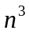 multiplications and 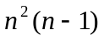additions. A more complex example is multiplication of two polynomials of degree ; this can be done with about 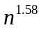multiplications, or better.
The fact that an algorithm is “polynomial” isn’t necessarily a sign that no more study is needed; polynomials grow plenty fast, and many polynomial algorithms become intractable even for reasonably sized problems. Problems without polynomial algorithms, however, are usually the ones labeled intractable since their growth in complexity is far worse than polynomial.
For example, consider finding the largest prime number evenly divisible into a given input. The best algorithm involves successively dividing the input by smaller and smaller numbers until no remainder is obtained. This divisor must then be inspected to see if it is a prime by dividing it by smaller and smaller numbers and verifying no remainder. For n input digits, the number of divisors to be considered is 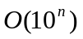 (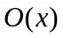signifies “on the order of x”), which is exponential in n, not polynomial.
Another example is the famous Traveling Salesperson problem. In this problem (which has many equally problematic variations), a hypothetical sales person must find the shortest tour of n points in a plane. Years of research suggest that there is no algorithm guaranteed to find the best solution except exhaustive search through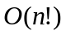 possible tours.

P and NP
It is customary to define the world of “reasonable” problems as P:
P: The set of all problems that can be solved by deterministic algorithms in polynomial time
Unfortunately, many problems do not seem to have polynomial time algorithms.
Some or all of these problems would be solvable in polynomial time, however, if we had a non-deterministic machine. The logic for developing these solutions is:
- (Magically) guess the correct solution
- Verify that this solution is correct and optimal
Problems for which the verification step can be performed in polynomial time are called nondeterministic polynomial (NP):
NP: The set of all problems that can be solved by nondeterministic algorithms in polynomial time
It is clear that any problem in P is also in NP.
The classic example of a problem in NP is satisfiability. This problem starts with a Boolean equation of the form:
Satisfiability asks if there is an assignment of logical values to the set of n 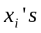such that the equation is true. The standard solution is to proceed with generation of all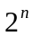input combinations until either a solution is found, or all possibilities have been exhausted.
It is interesting to note that no one has ever been able to prove that any problem is in NP but not in P; this suggests that there may be a polynomial time algorithm lurking out there that solves satisfiability. The theory of NP-completeness makes this extremely unlikely, however.

NP-completeness
The likelihood of finding a “good” deterministic algorithm for a problem in NP is extremely small. S.A. Cook proved that satisfiability is NP-complete in 1971. This means that if a polynomial time algorithm can be found to solve satisfiability, then all problems in NP can be solved in polynomial time. This very strong result forms the core motivation for the abandonment of the search for better algorithms and the development instead of different computing methodologies. The following problems, along with literally thousands of others, have been shown to be NP-complete:
PARTITION: Given a set of integers, can they be divided into two sets each of whose sum is equal?
INTEGER LINEAR PROGRAMMING: Given a linear program, is there a solution in integers?
MULTIPROCESSOR SCHEDULING: Given a deadline and a set of tasks of varying length to be performed on two identical processors, can the tasks be arranged so that the deadline is met?
VERTEX COVER: Given a graph and an integer N, is there a set of fewer than N vertices which touches all the edges?

Solving NP-complete Problems
The area of Artificial Intelligence runs into NP-complete problems almost continuously. Often, a clever attack can allow solutions to at least moderate instances of NP-complete problems. These approaches fall into three categories:
- Approximation Algorithms. Polynomial algorithms can often be developed which can be shown to generate suboptimal solutions to a specific problem. The discovery of such algorithms is very time-consuming, their performance is inconsistent and data dependent, and their applicability is typically limited to very specific problems.
- Average Case Treatment. By ignoring worst-case situations, polynomial algorithms can sometimes be found which usually generate optimal solutions. Again, this technique tends to be extremely application-specific, and the possibility of occasionally finding no solution at all is quite troubling.
- Efficient Exponential Algorithms. This requires the development of “branch-and-bound” algorithms which attempt to traverse the exponential tree as efficiently as possible. While such algorithms are still exponential, not polynomial, they can be effective in allowing traditional computers to attack much larger instances of the exponential problems.
This third area has given rise to forward checking, backtracking, iterative deepening, A* search, IDA* search, and a very rich array of techniques, tricks, and variations on themes which vastly increase the size of problems that can be approached with traditional sequential computers. However, these techniques merely postpone the inevitable, since a large enough instance of a exponential problem cannot be solved in reasonable time.
Unfortunately, the kinds of problems a cognitive computer would be expected to solve are almost universally exponential!

Thinking Algorithmically; 8 and 15 Puzzles
Almost any problem that requires many sequential steps for solution enlarges in complexity faster than any polynomial. This means that large instances of such problems have solution spaces that are unfathomably large.
For illustrative purposes, let’s consider the problem of solving an 8-puzzle. This is a toy puzzle in which eight tiles are set in a 3x3 grid in such a way that tiles adjacent to the one blank may be slid into the position of the blank. The goal is to get the eight numbered tiles into some desired state. Consider the following goal:

1 | 2 | 3
8 |  | 4
7 | 6 | 5
With the following initial state:
5 | 4 | 7
1 | 2 | 3
6 | 8
The first move must be either tile 3 or tile 8. This can be called Up or Left by considering the move to be the movement of the space either into the square occupied by tile 3 or tile 8, respectively. After this, three moves are possible from either new location. A move tree for the first three moves can be built up as follows. (Note that the “complete” tree has infinite depth and breadth!)
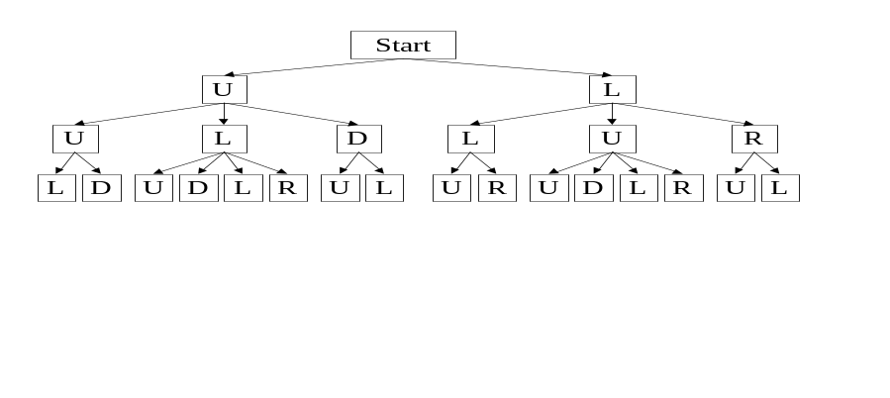
Figure 1: 8-Puzzle Search Tree, first three moves
Even in a simple game like the 8-Puzzle, the variety of possible moves is enormous. Since two moves are possible when the blank is in any of the four corners, and three moves are possible from each of the side midpoints, and four moves from the center position, the average number of possible moves is 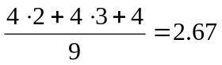. Thus, a puzzle which takes 20 moves to solve has a tree with 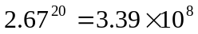paths. The actual number of starting situations is easy to compute. The first position can be occupied by any of 9 tiles, including the blank. The second position can be occupied by any of the 8 remaining tiles. Continuing in like fashion, the total number of 8-Puzzle situations is seen to be 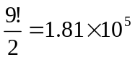. The division by 2 is required to preserve parity; since each move really is an interchange of the blank with a numbered tile, it is impossible to move an odd number of tiles! Thus, a desired final state may only be reached from ½ of the number of possible starting configurations.
A nice simplification arises from realizing that it is useless to move up followed by down, or left followed by right, since these move combinations simply return the puzzle to an earlier state. More sophisticated search algorithms attempt to extend this notion further by cataloging ALL previously visited states, and insuring that no state is ever visited twice. The relative expense of this operation makes its usefulness extremely situation-dependent.
At any rate, eliminating direct reversal cuts the tree branching factor from 2.67 to 1.67, such that a 20-move solution now requires investigation of only 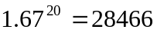 paths.
The situation rapidly deteriorates with scaling, however. A more complex version of the 8-Puzzle is the 15-Puzzle, in which 15 numbered tiles are set in a 4x4 grid. The rules are the same, although the complexity of the puzzle is much greater than is that of the 8-Puzzle. The following goal state will be used to allow analysis of the 15-Puzzle as a simple extension (although with extreme consequences) of the 8-Puzzle.

9 | 10 | 11 | 12
13 | 1 | 2 | 3
14 | 8 |  | 4
15 | 7 | 6 | 5

A similar analysis to that performed on the 8-Puzzle yields staggering results. Since two moves are possible when the blank is in any of the four corners, and three moves are possible from each of two side midpoints, and four moves are possible from each of four the central positions, the average number of possible moves is 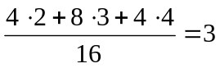. Also, 15-Puzzles take more moves to solve than 8-Puzzles. A 45 move solution, which is not atypical, would have a tree with 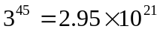paths. The actual number of starting situations is 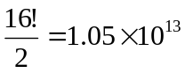. The division by 2 is again required to preserve parity.

Thinking: The Garage Door Problem
The Garage Door problem is a more typical real-world problem. This problem requires fewer moves to solve than an 8-Puzzle, but is confounded by an enormous branching factor. This is more common in real-world human situations, where the solution may only require two or three steps, but the number of “steps” a human could decide to take at any time is huge.
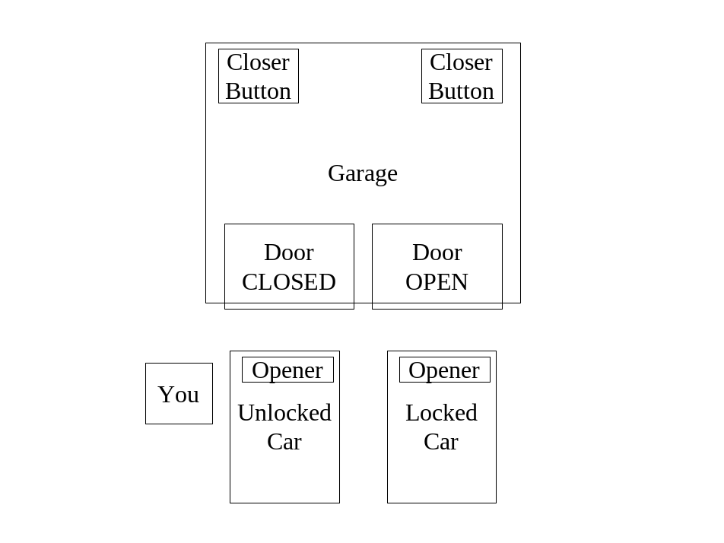
Figure 2: The Garage Door Problem
Two cars are in the driveway, each in front of its own garage door. Each car contains its own garage door opener clipped to the visor. There are two pushbuttons inside the garage allowing either garage door to be opened or closed from inside.
You are standing next to the car on the left. The garage door on the right is open. The car on the right is locked, and you do not have the key. Close both garage doors before you back out of the driveway in the unlocked car and go to work.
The solution, once the problem is understood, is obvious. Discerning this solution requires forward simulation of possibilities and consequences in exactly the same way that discerning an 8-puzzle solution requires forward simulation through the tree. In the case of the garage door problem (which I have had to personally develop real-time solutions for), the solution seemed trivial in spite of poor definition and an enormous branching factor. There are literally hundreds of actions that one could take at each turn, and yet we seem to not even consider them. For example, locking the unlocked car does not even seem to be a consideration in developing a typical human solution. How do we know to avoid this action?

Generalization to Games
The problems considered above are puzzles. The difference between “puzzles” and “games” is that in a puzzle there is only one brain involved, while in a game there are two or more. Games imply the notion of adversaries. Many people find puzzles “frustrating,” and games “challenging.” This is just a reflection of our survival programming.
Games can be roughly partitioned into two major categories:
- Games in which chance plays no role
- Games in which chance plays a role
Games in which chance plays a role typically require dice, shuffled cards, or some sort of randomizing device to inject the uncontrolled element of “chance” into the game.
Game play introduces a new element into “thinking,” since successful game play requires prediction of the actions of an opponent. The most likely way this is handled is to “put one in the place of” the other player, and try to select their countering moves based on an expectation of their style of play. This activity in itself may be cast as a puzzle.
The element of chance simply increases the branching factor at each level of the game tree, and requires the addition of a probabilistic element in helping to choose the “best” move. In real games, as in real puzzles, there is almost never an “optimal” move, since the definition of optimality is so dependent on individual assumptions and preferences which cannot be proven inferior or superior.

Evaluating Thinking Machines Using Puzzles and Games
A computing architecture capable of solving 8-Puzzles should be able to do a good job on the garage door problem, too, as long as the architecture is general-purpose and has no specificity to the 8-Puzzle problem itself.
Focusing on puzzles and games seems a reasonable way to explore cognitive behavior. If we can build a general-purpose machine that is exceptionally good at solving arbitrary puzzles and playing arbitrary games, we have come a long way in the development of “simulated reasoning.”
More importantly, though, puzzles and games provide a window on the strengths and weakness of the human mind. Most people like puzzles and games. The puzzles and games that we play are invented in other human brains. These “brain teasers” reveal a great deal about the capabilities of higher brain functions.
Humans easily tire of children’s games like tic-tac-toe, since it doesn’t take long for a human to become adept at playing to a draw every time. In fact, two marginally intelligent humans can play tic-tac-toe for a thousand years with every game running to a draw.
Consider that the situation is entirely different in Chess. Chess is “hard,” but millions of people play it passably well, and large numbers play it extremely well. A special-purpose computer plays it best.
If there are “easy” games, like tic-tac-toe, and “hard” games, like chess, are there “impossible” games? Not too many exist, since humans don’t invent games that are too hard, because we would be embarrassed by our inability to play. An example of a game that is probably too hard for humans to play is Morph Chess. In Morph Chess, imagine that each piece is identical, but has rules of movement that are dependent upon the last three game squares visited by the piece. Furthermore, all pieces have the same color, and it is the job of each opponent to remember which pieces are theirs. Our brains are just not “smart” enough to play this game.
Smartness, in this sense, seems more to be a hardware limitation, not an architectural or software limitation. In fact, a larger brain with a little more short-term or working storage would undoubtedly be able to play Morph Chess quite competently.
The justification for our lack of “scratchpad memory” is that solving problems like the garage door problem is a much more crucial skill to our survival than would be solving problems like the 8-Puzzle or playing Morph Chess.

A Learning Model for Puzzles and Games
This learning model does not attempt to describe how learning takes place; here, it is more concerned with what must be learned.
The primary human learning mechanism does not seem to be real-time trial-and-error. Actually trying something, like touching a hot stove, to find out that it is a bad idea is a very dangerous strategy. It would be quite difficult for someone to learn how to play chess by simply watching, say, 10 games played by grand masters. The intricacies of knights jumping other pieces, the allowed movement of each piece, and special cases like castling and queening would be hard enough to learn. Any hope at all of developing a strategy based on an analysis of only 10 games would be doomed to infantile play.
So how do humans learn? This is a difficult question, since learning goes on at so many levels in human thought. For our purposes, we restrict the question to “How does a human learn to play a game?”
This is an easier question to answer. We have all taught someone how to play a game. To play a game, we need to know what the game looks like, what the rules are, and what the object is. Call these Situation, Rules, and Goal. This will be referred to as the SRG Game Description.

Situation
The Situation of a game is the board, pieces, or other symbology arranged to represent a game situation. In chess, this involves understanding the 8x8 grid square of the board, being able to recognize each piece, and being able to differentiate between white pieces and black pieces. In an 8-Puzzle, this involves being able to read the symbols on the tiles, and seeing their respective positioning relative to one another.

Rules
Every game has rules, which may also be thought of as obstacles or impediments. In chess, the rules consist primarily of declarations governing how each piece may move, how play alternates, and a couple of special case rules, like castling and queening. In 8-Puzzles, the rules include just the restriction of motion to tiles adjacent to the blank.

Goal
The goal is the solution of the puzzle or victory in the game. In chess, this is checkmate, with a strong warning about the dangers of stalemate. In the 8-Puzzle, it is simply a picture of the desired location for the 8 tiles in the final position.
It seems that armed with an understanding of these three areas, humans can begin solving a puzzle or playing a game immediately. That is:
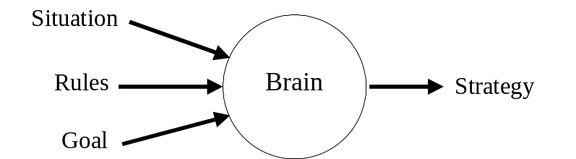
Figure 3: Synthesizing Strategy
Is there hardware in the brain that synthesizes strategy from an SRG description of a puzzle or game? It seems inescapable. But what is the nature of that hardware?

Neural Network Research
We have a fairly good understanding of how some neurons operate, although many details are elusive. Furthermore, there has been extensive experimentation with small networks specifically “trained” to recognize or classify in simple situations.
Unfortunately, most computer science research uses a neural model that is rather trivialized. More of the details on real neuronal modeling will be presented in the next section.
But building a neural network involves not only selecting the type and number of neurons. It also requires the placement of interconnections and personalities of synaptic boundaries.
The literature is full of ideas and variations on a basic theme; start with an arbitrary neural network, apply known inputs, compare to expected outputs, and try to "nudge” the network weights to decrease the error between expected and received output. These techniques are grouped under many categories, but can be thought of generically as “back propagation” for these purposes.
Much research has been done in the area of tuning simulated neural network weights to perform various pattern classification functions. In supervised learning, a set of input patterns is applied to a proposed network in conjunction with a set of desired outputs. The difference between the actual network output and the desired network output is propagated backward through the network in such a way as to suggest modifications to the network weights.
In practice, many factors influence how quickly, and how well, the network develops the ability to generate all of the expected responses. Many scenarios set up oscillations that prevent the network weights form ever reaching useable values.
These experiments generally rely on small, largely feed forward networks. Extensive networks, with many simulated neurons or many interconnections, or extensive feedback paths quickly overwhelm standard simulation hardware. Networks with more than a hundred or so neurons become very unwieldy, and are exceptionally slow to train.
If humans learned this way, it seems that it might have taken from the dawn of time until now for a single human to learn to skip a rock. Gerald Edelman, Nobel laureate in physiology and medicine, has said
Whatever the mind is, it is an ensemble property. That is to say it is a property of a collection of things, a very large collection of things, just as, for example, temperature is an ensemble property of molecules.
Imagine trying to understand the property of temperature by the study of a single molecule. It would be as futile as trying to deduce computer architecture by studying an AND gate, or worse, a single transistor. When we think in terms of individual neurons, or even small clusters of neurons, we make the task of deducing overall brain operation extremely difficult.
The key to understanding the operation of neural networks must come from a top-down, architectural model. How neurons work, and how they might be organized, is the topic if the next chapter.

Neuroanatomy and Neurophysiology : A Brief Tour
This section examines the anatomy and physiology of neurons, the brain itself, and sensory data processing mechanisms in higher animals.

The Neuron
It has been estimated that there are about 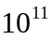 neurons in the human brain. Since many have interconnects that are tens of centimeters long, and since their interconnectedness is so prolific, it is likely that no brain cell is more than six or seven brain cells away from any other.
The whole brain is composed of more like 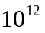 cells, with the other 90% that are not neurons being composed of insulating cells, blood and neurotransmitter transport networks, and perhaps a communications network or two. The exact behavior of this “other 90%” of the brain seems relatively simple compared to neural activity, but it might not be. Specific answers are not yet available.
An individual neuron might have several thousand axons from other cells inputting signals into it; a general rule is that the receipt of just a few messages from other neurons is unlikely to make a neuron fire. However, different signals get different weights. Certainly, axons connecting closer to the cell body have a better chance of making the neuron fire, much like the loud voices at the front of the room count for more “votes” in a voice vote. Cairns-Smith, for this reason, introduces the (still oversimplified) idea of the “Union Neuron,” in which the neuron takes a voice vote to decide whether to fire.
The processing, as opposed to memory, aspect of neuronal behavior is the more critical question regarding the workings of neurons for two reasons:
- Evidence is accumulating that suggests that memory operates in the brain at a level lower than the neuron.
- The development of a digital computational model of the brain only requires understanding of data access and processing; computer memory technology already far exceeds, in capacity and speed, the memory capabilities of any human.
This reasoning falls apart if the processing aspect of neural activity requires a specific form and function for the memory and learning aspects of brain operation. There seems to be a reasonable likelihood that the two systems, storage and processing, as it were, can be considered relatively independently.
It is tempting to think of the neuron as an inquiry/response kind of system: we apply inputs, wait, and then receive (possibly) an output. But there are many kinds of neurons, and each behaves differently. Many spontaneously active neurons have been found in both vertebrates and invertebrates, prompting physiologists to give them names like bursters and oscillators.
Much of our understanding of individual neuronal activity is due to the Nobel Prize-winning work of Alan Hodgekin and Andrew Huxley, two English neurophysiologists who in 1939 developed a wire electrode fine enough to be threaded into a squid’s largest axon, opening up the possibility for study of neuron response to synthetic stimuli. Their work, and the research their invention permitted others to perform, triggered development of a view of the neuron as a summing circuit, which somehow prepared a weighted sum of all of its inputs, and then fired, or did not fire, based upon the total sum.
This view of the neuron is woefully oversimplified, however. The electrical behavior of the neuron is based upon its ability to build up, and discharge, electric potential, a capability provided by the selective, controlled passage of sodium and chloride ions through various parts of the neuron membrane. Hodgekin and Huxley only hypothesized the existence of one trans-membrane channel for each ion, sort of a charging channel, and a discharging channel.
Since 1939, however, researchers have discovered at least ten additional ionic channel types, and most agree that many more await discovery. The electrochemistry of these individual channels is not important to this dissertation. Their effect, however, is extraordinary. Says Allport:
They are indeed responsible for the fact that one neuron is a spontaneously bursting cell that produces rhythmic bursts of action potentials without any synaptic input at all, while another is a silent cell that requires a long, slow stimulus before it will fire. They are also the reason that cells react to an injection of the same amount of positive current in quite different ways: one neuron might respond with a long train of action potentials, while a second shows no response at all; a third cell might bark – or fire - once, then remain silent.
Up through the 1960s, understanding the brain was thought to be a wiring game; if you could map out which neurons were connected to a particular neuron, you could deduce the function of the brain. The continued discovery of new, complex, and ever-more clever ionic channels in neurons began to make the emphasis seem like it should be more on the neuron, and less on the interconnects.
Gerald Fischbach, former president of the Society for Neuroscience, says, “One of the great embarrassments in neurobiology is that we don’t know whether there are thousands, millions, or billions of electrophysiologically distinct neurons.”
From a digital electronic standpoint, it is easy to think of the neuron as a generic logic gate. We have many different kinds of specific gates, with different properties, AND, OR, INVERT, One-shots, oscillators, flip-flops, and so forth. We can have edge-sensitive inputs, as well as open-collector or high-impedance outputs. It appears that by building the right ionic channels into a neuron, we could construct a biological version of almost any digital logic gate in common practical use.
There are some interesting developments in the area of neural interconnection, as well. Neural interconnections occur at synapses, locations where individual neurons come into close physical contact, but do not really touch. The transfer of information is carried out through the release of chemical neurotransmitters from one side of the synapse, and their attachment to receptors on the receiving neuron.
In the 1970s, it was thought there might be three or four such chemical messengers. Today, researchers suspect the existence of hundreds, each of which has special properties. Some remain in effect for as little as 10 mS, while others can linger for minutes, hours, or even days. Some are inhibitory, some are excitatory, and others seem to have a regional effect over any number of cells, as long as they have the right receptors. So much for wiring diagrams.

Neuron Summary
A thorough literature review on the state-of-the-art in the physiology of neurons and their interconnection would occupy volumes. Suffice it to say for now that there are many different kinds of neurons, much as there are many different kinds of gates in a computer system. Furthermore, interconnection between elements follows most of the rules of modern day digital design: the highest-speed connections must travel short distances, while lower speed connections can travel larger distances. Furthermore, when some special connection is needed from any point to any other, there is almost always a way to make the connection.
Just as fantastically complex computers can be built up from a relatively small set of logic gates, a brain can be built up from some reasonable set of neural building blocks. The challenge is in understanding overall brain architecture.

The Brain
A machine is explained in terms of physics and chemistry plus (at least) an engineer. An organism is described in terms of physics and chemistry plus (at least) evolution through natural selection.
A.G. Cairns-Smith
Modern humans are “the dazed survivors of a continuous, 5-million-year habit of lethal aggression.” This categorization is not intended as a springboard for social commentary; rather it reveals a way of exploring and analyzing the mind that may be more in line with the actual design principles that were in play during its evolution (at least, up to this point).
Much of the development of the human mind was required to insure survival during millions of years of evolution and savage competition. Our present behavior and “intellectual” pursuits (like the development of this dissertation, or even just reading the Sunday paper) are so far removed from 99.99% of our developmental history that it would seem naïve to use our present behavior as a case for describing the purpose for the brain.
That we can engage at all in more “intellectual” pursuits with the hardware at our disposal is a tribute to the generality and extensibility of the system. This fact does not, however, likely indicate that research on how modern humans think, from a behavioral standpoint, really reveals much about how the brain really works.
The neuron is not so much different from the other cells in our bodies. The only really new idea is “long distance telegraphy”, the use of action potentials to rapidly transmit information from one place to another. This form of communication is only in addition to, and not in place of, the standard chemical communications that constantly occurs between cells.
The following evolutionary discourse is largely due to Dr. Graham Cairns-Smith in Evolving the Mind (1996). In this book, Dr. Cairns-Smith provides an illuminating, insightful, readable and altogether enjoyable look at the physics and biology of human brain evolution.
The human brain is a highly evolved organ. This is to say that the brain is built from successively newer structures, and includes ancient places, and modified ancient places, as well as very new places.
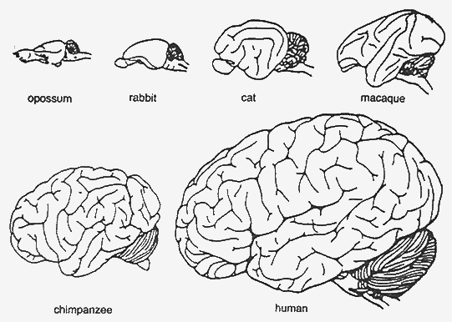
Figure 4: Respective Sizes of Mammalian Brains
Figure from Cairns-Smith (1996), p. 127
The figure above is a scale drawing of mammalian brains. Human intelligence is an enhancement on opossum intelligence, not something special or different in major ways. The most major difference between a chimpanzee brain and a human brain is simply size. The other differences tend to be evolutionary, rather than revolutionary.
It seems like it should be easy to figure out how an opossum thinks. If we can, we can probably determine how humans think, too.
Most of the recent development attributable to the development of higher intelligence has happened in the huge hemispheres of the cerebrum that occupy most of the skull. The cerebral cortex, which most call simply the cortex, is the familiar, convoluted outer shell of the cerebrum. The neocortex is the newest part of the cortex, and is widely believed to be the seat of higher intelligence.
Basic reflexive actions can be handled in simpler animals with just the “auto-pilot” type circuitry found in a ganglion. A few neurons can easily be wired up to, say, retract the gill in the sea hare Aplysia when it receives a startling shock. Over time, evolution created more complexe ganglia that expanded into a rudimentary spinal cord. Then the brain started as a swelling at the top of this simple cord, eventually dividing into a hindbrain, a midbrain, and a forebrain.
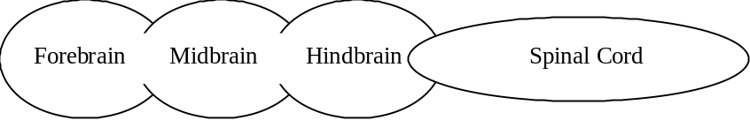
Figure 5: A Brain in Three Parts
The forebrain later subdivided into two districts, to give a set of five regions:
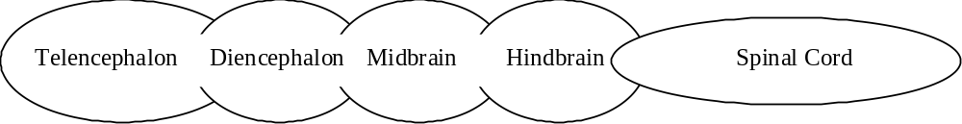
Figure 6: A Brain In Five Parts
Finally, a more complete structure evolved:
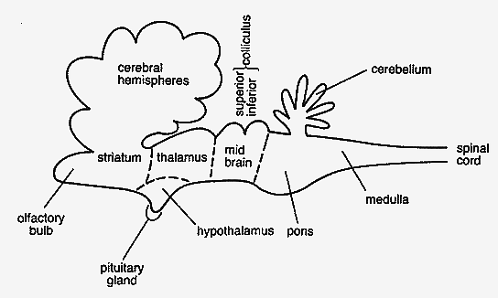
Figure 7: A More Complete Brain Schematic
from Cairns-Smith (1996), p. 129
From the bottom up:
Spinal Cord. Bilaterally symmetrical, and segmented, in that bundles of nerve connections repeat along its length. Here, the white matter (connections) is on the outside, and the gray matter (processors) is on the inside. Most processing here is restricted to tight closed-loop reflexes, although the more intricate parts of balance necessary for walking are automatically handled here as well. We couldn’t walk if our motor updates were only 3 or 4 per second. Also, the spinal chord processors insure that our finger is pulled away from the candle long before we register any pain.
Medulla. Remnants of the hindbrain are here. This is where most upper sensory and control connections are made, including hearing, control of face and eye muscles, and others. More importantly, control of the major organs, including heart and lungs, takes place here. This is a background process that is controlled and monitored perfectly well, even after massive damage to the cerebral hemispheres (permitting the existence of so-called vegetative state; someone who is alive but “brain-dead”).
Pons. A bridge-like swelling that may be thought of as a giant junction box, like the Main Distribution Frame in a telephone company central office.
Cerebellum. This is the first area of truly higher order processing. It may be thought of as the first draft of the cerebral hemispheres. This is where clever motor functions (riding a bike, juggling) are controlled. This may be thought of as the place where unconscious activity or expertise will be controlled.
Inferior colliculus. Now we’re up to the midbrain, in a region concerned mostly with processing of auditory information.
Superior colliculus. Some basic vision functions, such as lower order image processing and coordination of eye control.
Thalamus. Now we’ve reached the diencephalon, the lower half of the forebrain. This critical, fist-like structure is at the heart of brain structure, surrounded by the higher cerebral hemispheres, and heavily connected with them. This may be the central controller, or just a junction box, or something in between. The much smaller, but vital hypothalamus may play a key role here as well.
Telencephalon. This is the end of the line, at least for a few million more years. This region is dominated by the enormous cerebral hemispheres.
Cerebral Cortex. Now, the gray matter is on the outside, with the wiring on the inside. The cortex is a continuous sheet of cells 2 – 3 mm thick, and generally made up of six sub-layers of a large variety of different kinds of neurons.
Some cells, such as ‘chandelier’ cells and ‘basket’ cells make local connections, while pyramidal cells have long axons making connections elsewhere. Pyramidal cells in the upper layers of the cortex connect to lower layers below, while pyramidal cells in the lower cortex make connections to places outside the cortex, such as down toward the thalamus.
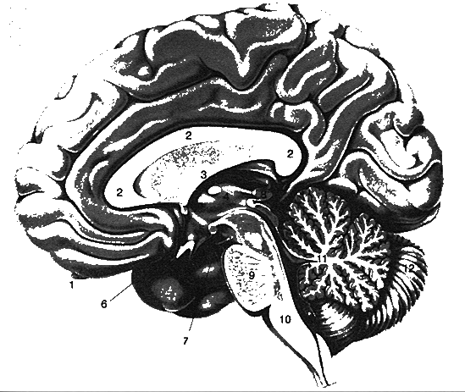
Figure 8: Brain Structure
1 Olfactory Bulb
2 Corpous Callosum
3 Formix
4 Thalamus
5 Hypothalamus
6 Optic chiasma
7 Oculomotor nerve
8 Pineal body
9 Pons
10 Medulla oblongata
11 Vermis of cerebellum
12 Right hemisphere of cerebellum
Figure from Cairns-Smith (1996) p. 133
The Cortex is where the action is, at least from a processing standpoint. The cortex is divided up into several regions, called the frontal, parietal, occipital, and temporal lobes.
The original cortex is small and obscured in the modern brain. The preponderance of the human cortex is neocortex, or the new extension to the cortex. It is exactly these new structures that we must look at to see where the difference between human thought and lower animal thought is built.
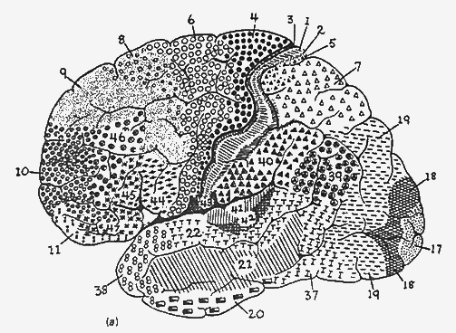
Figure 9: More Detailed Cortical Map
From Cairns-Smith (1996), p. 139
The map above, first developed by K. Brodman in 1914, reveals a richness and diversity in the processing hardware architectures devoted to different activities. While the neocortex is built from the same components, it exhibits different structure and interconnection patterns in different regions of the brain. In fact, though the general architecture of the neocortex seems consistent in some generic way throughout, the specialized regions are definitely wired differently, composed of different flavors of neurons, and connected to different I/O. A decent, but oversimplified, map of these regions is shown below.
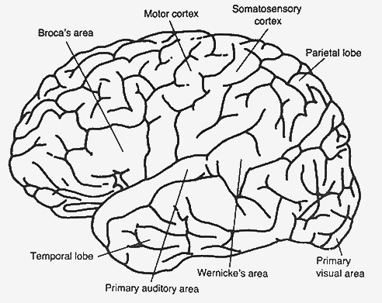
Figure 10: Some Intemediate Cortical Detail
Figure from Cairns-Smith (1996), p. 140
The visual and auditory areas are clearly shown. The Somatosensory cortex is a region onto which are mapped the control and sense connections to individual body parts. Next forward is the motor cortex, a region onto which are mapped everything from our toes to our lips. Especially dexterous regions, like the hands and the facial muscles, have a much larger region of motor cortex dedicated to them.
The sensory and motor portions of the neocortex consume about 25% of the device. Forward of the motor cortex is the premotor cortex, which shows signs of intense activity just prior to our initiating complex actions. It is thought that planning of complex motions is carried out here.
This behavior is crucial to understanding the processing methodologies to follow; it appears that the brain “works things out” in advance by simulation or trial-and-error. True simulation trial-and-error is a much safer activity than real-world trial-and-error. This methodology may carry over to higher brain functions.
The “planning” and “working-things-out” nature of the neocortex seems only to increase as we move forward further; we find regions neuroanatomists call association areas, in which associations, analysis, and synthesis presumably occur.
Some other interesting portions of the neocortex include a region underneath the temporal lobe specifically involved in face recognition. From an evolutionary perspective, face recognition is crucially important enough to survival and procreation that it makes sense for us to have a specialized region for it.
Other regions of special interest are Broca’s place and Wernicke’s place. These regions are associated with speech generation. Broca’s place is concerned with grammar; with a damaged Broca’s place, you might know what you want to say, but have trouble assembling words into a coherent and correctly constructed sentence.
Wernicke’s area is concerned more with global meaning; if you have a damaged Wernicke’s area, you might speak grammatically correct, but nonsensical, sentences.
A more stylized, but still anatomically correct schematic drawing of the neocortical connections (with the exception of the frontal lobe structures for analysis and planning) is shown below.
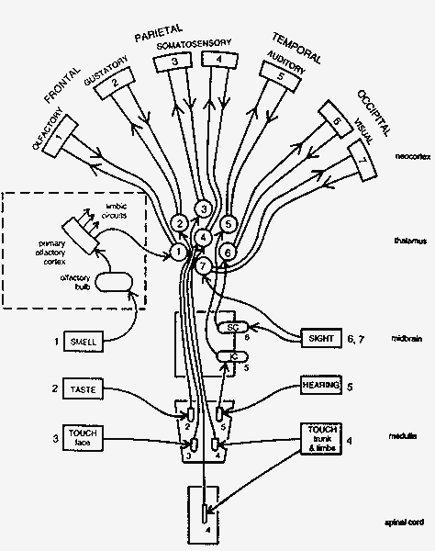
Figure 11: Thalamic Input Preprocessing
Figure from Cairns-Smith (1996), p. 159
From an engineering perspective, it is easy to imagine a computation system with similar regions in it, each designed specifically for a similar subtask. A remaining question is that of interconnect; indeed, in most advanced computer architectures (and it is correct to consider the brain an advanced computer architecture) the wiring and interconnect scheme is the most critical, and often the speed-limiting, factor.
So how is the cortex wired? The impression of neuroanatomists is that the cortex is almost fully interconnected; ribbons and bundles of axons are connecting almost every region to every other region.
The wiring is highly organized and compact. The atlas figure below shows how some major bundles are routed in one hemisphere.
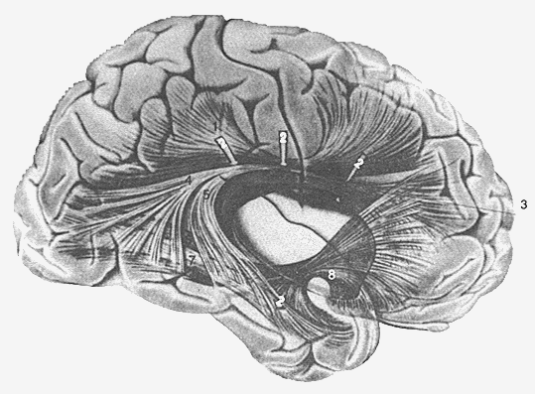
Figure 12: Internal Brain Wiring Pathways
Figure from Cairns-Smith (1996), p. 144
The star of the cortex-cortex (corticocortical) connections is the corpus callosum, a massive bundle of interconnects between the two hemispheres. Many “split-brain” experiments have been carried out on patients whose corpus callosum has been surgically severed, primarily in the treatment of severe epilepsy. Epilepsy triggers severe “seizures,” episodes in which the brain engages in uncontrolled feedback. Severing the corpus callosum is one (extreme) way to reduce the possibility of feedback loops.
In addition to the corticocortical interconnections, there are many input/ouput connections, which neurobiologists refer to as “projections.” Primary among these is the corona radiata which connects the cortex to central structures which can be thought of as “downtown brain.”
The center of the brain contains complex, ancient structures, grouped primarily due to their spatial locality under the heading limbic system. The limbic system includes the hippocampus, widely held to play a large role in long term memory.
It seems the hippocampus was once a more central structure, actually larger than the neocortex in the shark brain, a very ancient design. In mammals, even as primitive as the rat, the neocortex already dwarfs the hippocampus. These changes are shown schematically in the figure below.
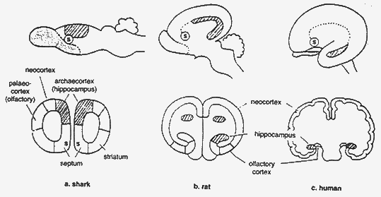
Figure 13: Neocortex Explosion in Humans
Figure from Cairns-Smith (1996), p. 146
In this figure, it is also possible to see the migration of the septum, another limbic structure, although in humans it maintains its tight connection with the hippocampus through an extended wiring interconnect known as the fornix.
A number of other ancient, complex, and mysterious structures reside in downtown brain, as shown in the figure below. The exact operation of each remains in dispute, although a great deal is known about the behavior of patients who are missing one or more of the structures. The removal of such a structure causes so much collateral brain damage (and is only inflicted as a solution of last resort on extremely abnormal people anyway) that such studies are hard to interpret with confidence.
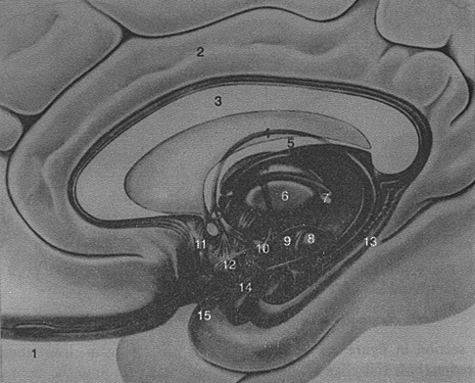
Figure 14: Downtown Brain
Figure from Cairns-Smith (1996), p. 148

Brain Signal Input Conditioning
This brief introduction is focused primarily on the processing architecture of the brain, but input signal conditioning undoubtedly plays an enormous role in shaping the processor designs. As a means of introducing this kind of signal conditioning, let’s look briefly at the input processing of the human’s most complex sensory system; the eyes.
The human retina, located at the rear of each eye, is composed of about 180 million rods and cones, cells which respond to light in three different color bands.
We commonly think of these bands as red, green, and blue, but they are actually broadly centered on 420, 530, and 560 nm, and overlap significantly. Furthermore, the response bands are not very sharp; many colors significantly stimulate all three receptors. To perceive a color, we must compute and integrate signals from all different bands.
The 180 million rods and cones of each eye are reduced to about 1 million nerve signals on the way to the brain. This reduction is effected through averaging, differencing, and several other direct data reduction strategies. Here, the summing (and differencing, using inhibitory inputs) capacity of the neuron is used to great effect.
The 1 million input signals first reach the optic chiasm, where they are redistributed. Then, they pass to the left and right lateral geniculate nuclei (LGN) of the thalamus. This wiring structure is shown below.
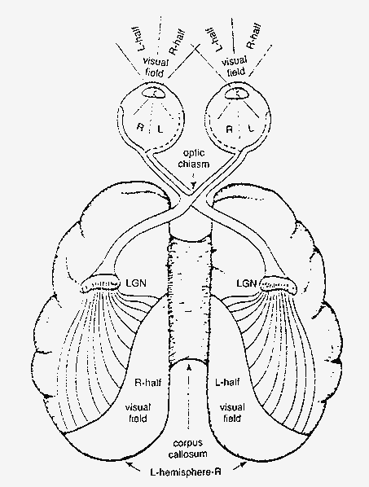
Figure 15: Optical Routing via LGN
Figure from Cairns-Smith (1996), p. 163
The LGN is a powerful filter bank, performing detailed processing and reprocessing of the vision signals. A structural detailed analysis of the LGN is shown below.
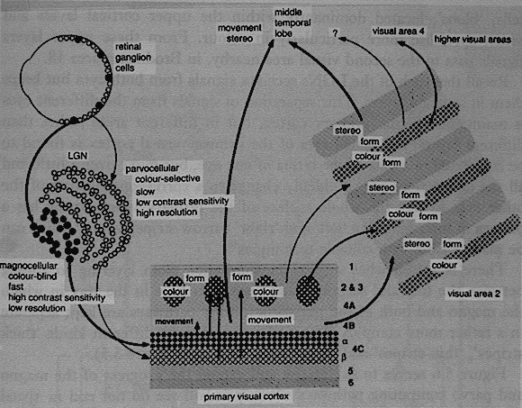
Figure 16: Detailed Map of LGN Interconnection
Figure from Cairns-Smith (1996), p. 165
This processing highlights motion, edges, angles, colors, and a variety of other features of interest before passing these multiple data representations on to the visual cortex. This arrangement of data makes the information particularly well suited to associative processing; that is, processing in which the feature of interest are not necessarily known a priori, and which only become recognized as the features of interest after analysis. A block diagram of this processing is presented below.
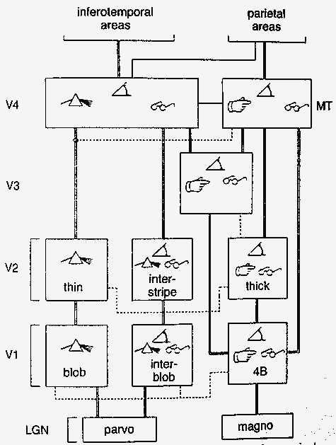
Figure 17: Approximate Visual Filter Bank
Figure from Cairns-Smith (1996), p. 167
This type of feed-forward signal conditioning and repackaging is easy to implement with neurons. It insures that a marvelously rich and information-packed array of data is available to the cortex for processing. A reasonable processing model for such data is the primary goal of this dissertation, and one will be described in the next section.

A Model for Brain Operation
The brain exists, and it works extremely well. Were it not for this fact, we would probably think it impossible (if we could think at all). Today, neurological evidence and psychological research seems to point to the fact that the brain is a machine, admittedly a complex one, but the apparent complexity is undoubtedly compounded by the fact that we don’t understand how it functions.
Understanding the nature of birds turned out to not be important to Orville and Wilbur Wright, who ignored legs, feathers, flapping wings, rear-mounted control surfaces (though these came back later), and a plethora of other physiological, chemical, and neurological information about birds in the construction of the first self-powered airplane.
Similarly, we can ignore a great deal of baggage of the mind in attempting to design new computing architectures. Some of this baggage would be:
- The power of self-repair. This is not important to us at this time. We can repair the machines ourselves.
- The capacity to reproduce. This is probably not recommended, even if we knew how to do it.
- Obsession with survival. A new system does not need to be able to defend itself to be intelligent and useful.
- Extreme motion control and dynamic control capability. Modern computer technology can perform closed-loop control far more accurately than biological systems. What has been missing is the real-time intelligence to specify what actions need to be performed to accomplish a task.
- Evolutionary baggage. Many brain structures (and related human behaviors) carry over from times lost. Reproducing evolutionary structures is not required in a design-from-scratch.
- The miracle of memory. Digital technology has this problem solved quite nicely. Digital memory accuracy, size, and access speed exceeds human capability in all areas except arbitrary associative retrieval, which can be an algorithm, not a storage technology.
- Core technology. The brain is chemically-powered. This makes sense for biological systems, but there is no evidence that chemical power is a requirement for duplicating brain intelligence.
In contrast, many properties of the brain must be key ingredients in the construction of intelligent machines. A proposed list of these properties follows.

Cortex and Downtown as the Computing Machine
It has long been believed that the convolutions and folds of the cortex have something to do with intelligence, since they are most pronounced in the human brain, and become less and less pronounced as we examine the brains of simians and lower mammals. This strongly suggests that increasing the surface area of the cortex is somehow required for increased intelligence. The obvious way to increase cortex area is to simply increase head diameter. The reasons for not expanding head diameter are twofold:
- Big heads are very difficult to pass through the birth canal
- In increase in head radius of r increases cortex area as 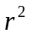, but increases wiring volume as 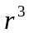; perhaps the area increase of the cortex is more valuable than is the wiring volume.
It is safe to assume that both factors play some role; however, natural selection has overcome numerous mechanical problems easily in the past. It is tempting to imagine the first Cray supercomputer, with processing boards huddled around a central wiring column to keep the interconnectedness high and the length of their connections (and associated communications delay) short. The increase in cortex area through convolutions accomplishes the same wiring goals while allowing a vast increase in the area of the cortex.
As an aside, the cerebellum is organized much like the cortex, although with much tighter convolutions and less white matter. This is analogous to a further reduction in feedback path propagation delay, which is precisely what we would expect for the ancient, “subconscious” cerebellum.
It is interesting to pause for a moment and ask the question, “Why so much wiring in the cortex?” The answer may have to due with programmability. The cerebellum is an ancient structure. It evolved long before humans were capable of performing what we today would consider to be intellectual tasks. It is special purpose, and is wired to perform very specific motion control and dexterity kinds of functions.
The higher processing region of the brain, the cortex, must be much more configurable. It can play chess, solve problems, and analyze situations in an ever-changing, continuously variable way.
There does not appear to be “software” or “microcode” in the brain; that is, there is no central data store of program instructions that are uploaded into general-purpose hardware on demand to reprogram pieces of the system. This is a great architecture, but it does not appear to be part of brain design.
Instead, the brain seems to be much more of a hardwired computer. How does one make a hardwired computer dynamically reconfigurable?
One architecture would be to take a processing unit and hardwire it for several different tasks, adding a few extra control inputs that effectively disable the connections that are inappropriate for the computation currently desired. This approach has the disadvantage of dramatically increasing interconnect requirement, as well as computational unit fan-in. At the same time, though, it does make for a simple, robust, reconfigurable system based on the hardwired paradigm.
I was fortunate enough to have the opportunity to work with an older analog computer in the early 1980s as an undergraduate. Programming the system was accomplished by connecting integrators, differentiators, filters, and summers using patch cords. The programs I “wrote” with the cords were simple, but my machine always seemed to be covered with piles of patch cords. Some were completely connected, some were only connected at one end, as I figured out where they should go, and some were connected at one or both ends between unused circuit elements without effect as a result of being left over from the last “program.”
I saw a computer that was extremely neat, one day. My professor had set up a static demonstration, and had neatened up the patch cords, using as few as possible to make the circuit more understandable and compact. My machine could never look like that, it was constantly being set up for new and different problems.
The neat analog computer is like a circuit in the cerebellum, implementing a program developed through natural selection millions of years ago. This program won’t be changing any time soon. The cortex is more like my computer, though. Wires everywhere, a system in transition. In fact, several different programs could be set up simultaneously, and each independently activated by just moving one or two of the myriad circuit connections.
Hardwired computers can be made dynamically reconfigurable, but at the cost of enormous growth in simultaneous interconnect, only a tiny fraction of which is actually significant at any time.
In this way, we can think about the neuron with 10,000 inputs as a simple analog computer that can be called upon to perform many different tasks at any time, simply by setting up the right control signals to help it choose which inputs to examine and which to ignore.

Memory Divided in a Procedural/Declarative Arrangement
Cognitive psychology has proposed many models for human memory. While many of the characterizations are difficult to distinguish because of the behavioral analysis common to cognitive psychology, there seems to be a fundamental distinction between procedural memory and declarative memory.
Procedural memory is memory of how to do something, like riding a bike, or running up hill. This memory is automatic, highly robust, very fast, and difficult to verbalize. It is hardwired memory, much like the structures in the cerebellum, not having many connnections to the “conscious” centers of the brain, but breathtakingly precise, robust, and fast.
Declarative memory is more concerned with facts and data. This type of memory may be implemented in a greater variety of ways than may be procedural memory. A good guess is that declarative memory involves characterization of information based on a set of basis relations. These basis relations are developed early in child development as a result of sensory input stimulation patterns; patterns that occur frequently are “grown” several basis neurons which fire when those frequent patterns are seen. By continuing this “growth of basis” procedure over the life of the individual, complex memories can be stored with fewer and fewer references. As a side effect, these models are imposed on actual situations, causing us to perceive certain attributes in certain situations, whether the attributes are present or not.

Size is REALLY important
The size of the machine, that is the number of neurons and interconnects, is very important. A fly has about 10⁶ neurons. A human has more like 10¹¹. While it is true that flies have very impressive 3-D flight control capabilities, the computational region of interest for this research is much closer to the billion-neuron level than it is to the million-neuron level.
Looked at another way, the human cortex, flattened out, has roughly the area of four standard sheets of paper. A chimpanzee has one sheet of paper. A rat has a postage stamp. While researchers are impressed with the capabilities of chimpanzees and rats in the laboratory, a useful new computing machine needs to have intelligence at the four-page level, not the postage stamp level. If scalable (and the design must be scalable, at least to 4 pages), it would, of course, be interesting to try out a ten-page version.
The development of a powerful new computing architecture probably requires that the scale be enormous by modern parallel processing standards. This means that a practical system requires simple, low-level hardware processors to allow fabrication of millions of processors using digital logic techniques.

Data Storage and Data Processing are Separate
It is reasonable to assume that the storage of knowledge and the application of knowledge to solve a problem (cognition) are handled differently in the brain. Consider that it is possible for one to be “quick-witted” without knowing the slightest thing about a huge variety of topics. In addition, it is possible for one to be a “walking encyclopedia” of facts regarding a plethora of topics and yet to be utterly incapable of applying any of the knowledge in a practical way. This concept of memory vs. processing is familiar to traditional computer design, and will be assumed henceforth. There is experimental evidence in some of the fringe work of this dissertation that suggests that the processing scheme proposed herein can be used to optimize complex memory storage and retrieval problems.

Many general-purpose CPUs give the most flexible design
The human cortex is a sheet of generally six layers of neurons covering most of the outer surface of the brain to a depth of 2-3mm. This is the “gray matter,” know by neurologists and biologists alike to be the locus of the conscious processing units in the brain. The inside of the brain (the “white matter”) is mostly wiring.
The layers of the cortex contain a variety of cells known in neurological circles as chandeliers, basket cells, pyramidal cells, and so forth. The key to the differences between these cells is unclear, but some cells have local wiring, and some connect far, far away.
The quantity of neurons in the cortex are most developed in humans; indeed, mammalian, and ultimately human, brains evolved ever more convoluted surface contours to increase the area of this cortex region.
The neurons of the cortex are further organized into macrocolumns, cylindrical groups of 1000-10,000 neurons and 0.5 mm or so in diameter. A human has perhaps one million of these macrocolumns spread out over the cortex. Some are known to be associated with visual processing, some to be associated with hearing, or speech. Some are associated with complex movements and hand-eye coordination. (More coarse motor control is handled in the evolutionarily ancient cerebellum, a processing site shared by much lower forms of life.) In addition, the area of the brain associated with planning and strategy lives in the cortex, mostly in the frontal lobe.
The interesting feature of the cortex is that the processing macrocolumns, while associated with different types of cognitive activity, seem to have a somewhat uniform architecture. That is, there seems to be a processing macrocolumn in the cortex that is capable of performing a variety of cognitive tasks. The largest reason for the localization of certain tasks to certain regions seems to be the choice of what inputs and outputs happen to be connected to the macrocells.
On close examination, the cortex is complex, and not as uniformly organized as we might like. But at the right resolution, this pattern of macrocolumns that are heavily communicating internally and lightly communicating externally is real.

Wiring dictates behavior
The macrocells look like some sort of hardwired computer. This is actually possible since the typical neuron may have over ten thousand inputs, not all of which need to be activated to fire the neuron. That is, the neuron may be made to fire by any one of a number of different input conditions, each of which may be stimulated by totally unrelated groups of inputs.

The Constant Drive of Evolutionary Goals
In studies of primitive man, we generally get the impression that early humans only thought when they were hungry. Indeed, it can be argued that written language was invented for the purpose of advertising salt for sale along the ancient trading lanes in Mesopotamia and Sumeria. It is important to think of the brain in the context of its evolutionary success, and the kinds of advances that insured that success.
An analysis of the brain can benefit from consideration of the evolutionary goal placed upon it; survive. A more formal statement, in order of importance, could be:
- Stay Alive
- Reproduce
Let’s focus in on goal #1, and expand it:
- Enhance likelihood of survival
- Diminish likelihood of death
- If nothing needed at 1a or 1b, avoid conflict
This description of the cognitive process provides a very interesting insight into the question of why humans love to play games. We can restate the subgoals above as:
- Win
- Don’t Lose
- If you can do neither 1a nor 1b, Draw
This is, of course, simply human game playing behavior, and a crucial description of the essence of strategy.
Games and puzzles are merely low-risk ways for humans to practice survival skills. This viewpoint will shape and justify the development of the new computing architecture to follow.

A Computing Architecture
This dissertation now proposes a new computer hardware and software architecture that more closely duplicates human intelligence. Necessarily, the design must start with a definition of “intelligence.”
Intelligence is the art of seeing things hidden. It is the generation of a new piece of information spontaneously from old information. Our most intelligent ideas are called “flashes of inspiration.” This all points to a critical idea: “Intelligence” requires a non-deterministic step. Intelligence is identified from random assemblages of known information whose correctness can only be verified after undirected assembly.
That is to say, we randomly associate ideas with one another, reject the combinations that are foolhardy, and declare our brilliance by loudly announcing those that make sense.
This casts the “algorithm” of intelligence as a restatement of the definition of problems in NP.
How does this notion apply to the solution of our test puzzles? The puzzles represent a daunting challenge only because of the size of their solution trees. An easy way to search a complex tree is to search it randomly. In this way, we hope to get lucky and stumble onto a reasonable solution.
In a serial computer, this strategy is doomed to fail for non-trivial problems, since the likelihood of finding a solution is so small. In a parallel system, however, where 100,000 processors might be simultaneously performing random searches, the likelihood of finding a solution increases 100 thousand-fold. Furthermore, once a single solution has been found, the number of iterations in each processor can be limited to that solution depth and processing continued at an ever-faster rate in hopes of finding a better solution.
There are many biological motivations for this design. The clearest motivation, however, is the simple fact that the postage-stamp sized cortex in the rat has verifiably less power than the sheet-of-paper sized cortex of the chimp, which has decidedly less power than the 4-page human cortex. Hook up 400 in² cortex to a rat, and I’m quite sure it could beat Gary Kasparov in chess, although it might have to signal its moves using sign language.
The logical steps required in puzzle solving, which is a generic form of general problem solving, may be laid out as follows:
- Set up N processors for the problem at hand (BIG N)
- Input initial Situation to all processors
- Each processor runs steps 4-6 in a loop until halted
- Is current Situation the goal-state? Yes; halt and shut down (or ignore) other processors
- Generate random next move, based on allowable moves
- Compute new Situation; goto step 4
This idea is simple, and easy to convert into hardware. An enhancement to the idea of “allowable moves” at step 5, enabling alternation of the play of self and an opponent, opens up the door for move selection in games.
The next section proposes the first real electronic design. It has critical weaknesses, but these will be corrected in the next version.

The Wanderer
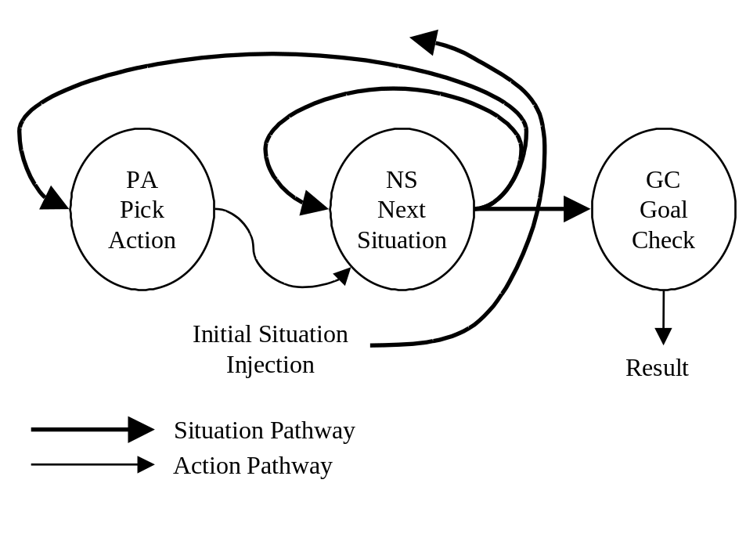
Figure 18: The Wanderer
A computer operating on the proposed principles would essentially “wander” through the state space in a completely undirected way. The hardware version of Wanderer is a state machine that generates the next move based on the current Situation and the rules of the puzzle. It iterates until it hits a goal, or until it runs out of time.
As a piece of traditional computing hardware, this design is quite useless. If the first action chosen, for example, is an interminable dead-end, the circuit will run forever without finding a solution. If we have 10,000 circuits running in parallel, however, there is a much larger likelihood that at least one Wanderer will find a solution.
Once a solution is found, better solutions may be searched for more efficiently. In problems that have uniform cost per step, any Wanderer still running when the first Wanderer finds its solution may be reset. Now all Wanderers may be rerun for the amount of time the first solution took to generate. This process may be repeated several times, until little progress seems to be forthcoming in reducing solution length.

8-Puzzle Wanderer Simulation
A formal wanderer simulator was developed in C to reveal some of the details of the device. This coding example is included in Appendix A.
For this example, the wanderer’s situation pathway carries a vector of 10 integers, representing the grid contents, followed by a redundant data element specifying the location of the blank. This redundant data item allows the move generator to find the blank without iterating through all of the puzzle tiles. This was done initially as a performance enhancement to speed the simulation, but opens up a much richer discussion on redundant data formats for later.
The wanderer’s action pathway in this example contains integer pairs specifying where to move the blank from, and to. For example, moving the blank from the center to the middle of the top row is action 4,1.
Many runs of various random 8-Puzzles were executed using 100,000 wanderers. To reduce the results into a more understandable form, Wanderers were restricted to a number of iterations equal to the best solution found so far. In this way, poorer solutions were never reported. This modification may also be useful in practical applications of Wanderer.
Three data runs are tabulated for the puzzle below, which was generated by making 1,000,001 random moves from the traditional 8-Puzzle goal state.
1 | 8 | 3
 | 4 | 2
5 | 7 | 6
The run results are shown below.
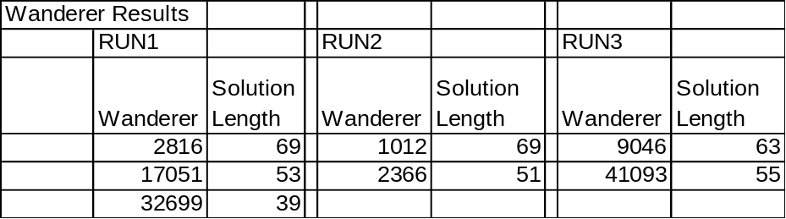
Table 1: Wanderer Results
The interpretation of these results is as follows. In Run 1, the first 2815 wanderers found no solution. Wanderer 2816 found a solution of length 69 moves. Wanderers 2817 through 17050 found no solution better than 69. Wanderer 17051 found a solution of length 53. Finally wanderer 32699 found a solution of length 39, and wanderers 32700 – 99999 found no better solution than that.
Of course, if 100,000 wanderer circuits had all been running simultaneously, the actual run time of the entire operation would be just the time taken by the wanderer finding the shortest solution, since it finds the solution first.
These wanderer results, however, should be considered poor for two reasons:
- 8-Puzzles rarely take more than 20 or so moves to solve, making these solutions look rather suspicious.
- The results are highly inconsistent, yielding solutions of length 39 to 55, after even 100,000 wanderers have run. This indicates an unreliable solution engine.
A theoretical analysis of the effectiveness of wandering will be undertaken shortly. First, however, it is possible to make some improvements by correcting a glaring shortcoming of wanderer.
A large problem with this kind of random search is regeneration of previously investigated pathways. This problem is familiar in the directed-search AI community. Unfortunately, repeated state avoidance can be more complex than is the actual search methodology! A hardware circuit implementing repeated state avoidance would require a huge set of temporary memory and the ability to build an indexed database in it, and this design is neither practical nor supported by anatomical evidence.
There is, however, a simple enhancement to wanderer that drastically reduces repeated state visitation without adding much hardware. In most puzzles, there are retreats; that is, actions that cancel out previous actions. For example, moving the blank up one position in an 8-Puzzle, and then moving it back down to the previous position, returns the puzzle to an identical state.
In general, puzzles have many complex cyclic move combinations which may qualify as retreats. Complex situations, however, are less prevalent than are simple retreats which just involve going back the way you came. By adding an exclusion capability to the random action generation step, we can avoid these immediate backtrack moves and greatly increase our search efficiency.
This is the concept of the scout, the core hardware design concept of this entire dissertation.

Scout
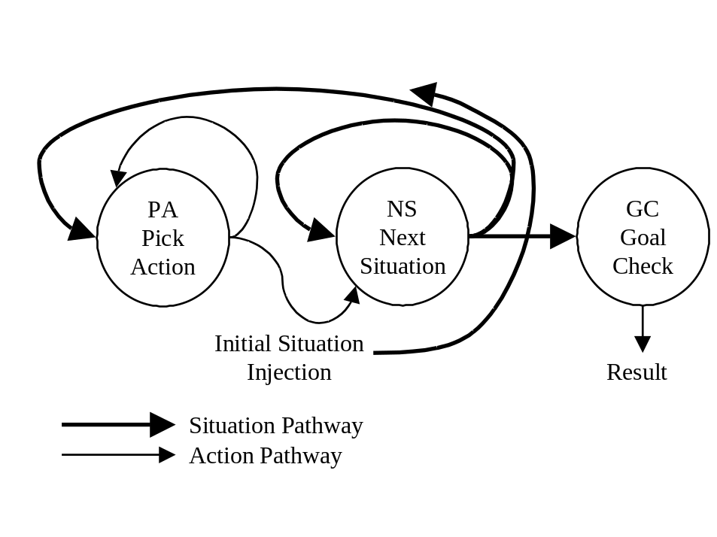
Figure 19: The Scout
The only difference between wanderer and scout is the addition of a feedback path from PA to itself. This represents PA having memory of the last action generated, so that it can avoid generating a backtracking move that would cancel its previous move. In general, one can think of the PA block as having a move FIFO inside it. This FIFO maintains a small list of the last few moves made. Depending on the puzzle, additional logic can be added to PA which simply excludes consideration of any move that would represent a retreat.
This requires a little more state memory per scout, but vastly increases the thoroughness of the random search.
This property will be demonstrated in the following simulation.

8-Puzzle Scout Simulation
The C simulation of Wanderer may be enhanced to a scout simulation by a simple modification of the GenerateRandomAction(…) procedure to use the previous action as a exclusion operator to prevent a direct retracing of steps to be taken. This modification is shown in Appendix B.
This particular implementation considers only a move FIFO one move deep, and will only avoid going immediately back the way we came on the previous move. The effect that this simple modification has is important. Recall that the average branching factor (number of possible moves) in an 8-Puzzle is 2.67 (four from the center, 3 from the centers of each side, and 2 from each corner). Elimination of direct backtracking (that is, move up followed by move down, for example) reduces the branching factor by one, to only 1.67! This is a huge reduction in the size of the search tree, and is realized with minimal additional hardware.
Many data runs were performed with scouts on 8-Puzzles. The results reported below are typical.
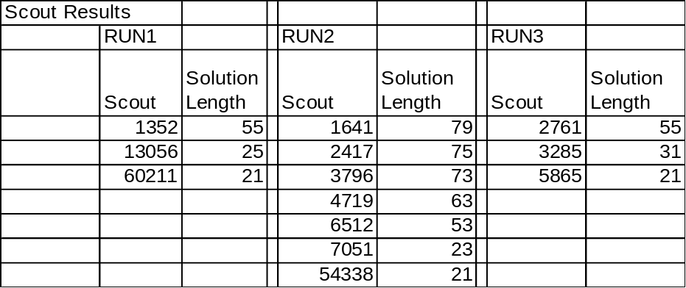
Table 2: Scout Results
In these three scout runs, an identical solution of length 21 moves was found every time. The first run took over 60000 scouts to achieve this solution, while the solution was found in fewer than 6000 scouts in run 3. Many more runs duplicate the same behavior, with the scouts finding this believed-optimal solution almost every time.
It is instructive to back away from the C simulation for a moment, since the simulation runs scouts sequentially.
Imagine a system of 50,000 scouts setup for 8-Puzzle solution. Since the worst-case 8-Puzzle takes less than 30 moves to solve, we could run all 50,000 scouts for 30 moves and if no solution was found, reset them to start from scratch again. By the time we performed this reset four times, 200,000 scouts would have searched for the solution. The preliminary simulation data says we’ll almost always have the solution by this time (the proof of this comes later in the dissertation).
In this way, our scout network would solve arbitrary 8-Puzzles in the time it takes to generate no more than 120 random 8-Puzzle moves. If the scouts were crafted from present ASIC finite state machine technology, they could move forward through at least 50 million moves per second. At this rate, complete solutions to arbitrary 8-Puzzles would be found in approximately 2 uS.
With only 1000 scouts, we’d have to reset 200 times before a solution was likely to be found. Still, this only represents 6000 machine cycles, or 0.12 mS.
In the next section, a hardware architecture for scout will be proposed that could run at 100 MHz.

Scout Hardware Implementation
A hardware block diagram of scout is shown below. The PA (Pick Action), NS (Next Situation), and GC (Goal Check) blocks are simple combinational logic, so the only real challenge is insuring that the right states are applied to the combinational logic blocks in synchronization with one another. Effectively, we have nothing more than a recirculating state machine from classical digital electronics! Here is a sequential logic implementation.

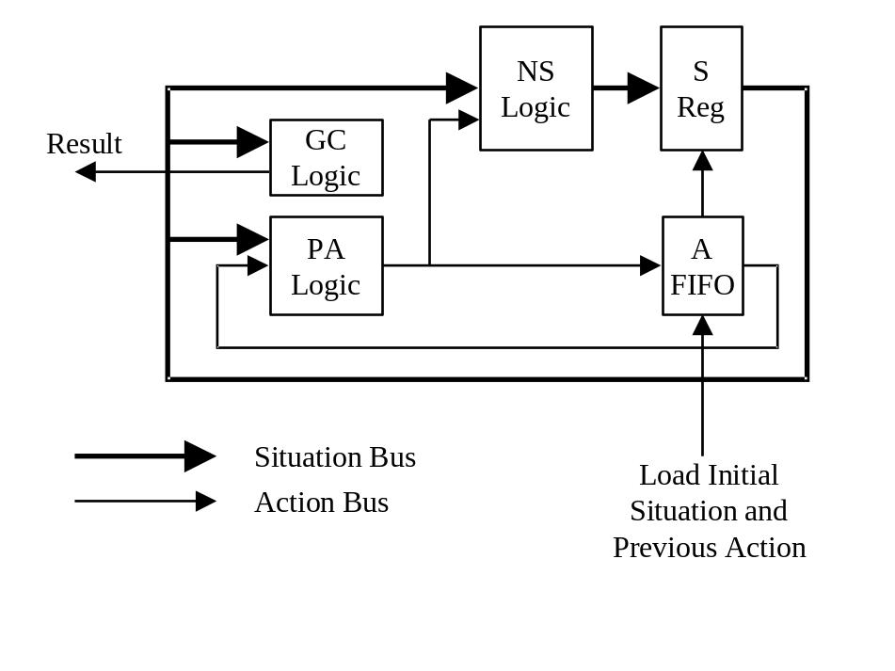
Figure 20: Scout Hardware Block Diagram
It turns out to be quite easy to implement the combinational portion of the 8-Puzzle engine in VHDL, which allows direct synthesis of a hardware circuit using commercial CPLD devices.
This actual construction of scouts is left as an “exercise for the reader,” and should offer ample opportunity for future research. In any case, fabrication of such devices is premature, since the initial look at scouting only worked with one fairly simple puzzle, and it would be desirable to show how the computational procedure can be generalized to more complicated problems. To this end, a theoretical analysis of scouting follows.

A Theoretical Analysis of Scouting Efficiency
The scout, as explored so far, grossly outthinks a human in solving the 8-Puzzle, since it can see the way fully and precisely to the solution, even if the solution is 25 moves ahead. Humans, lacking the high-speed, precise temporary storage of digital systems, will never match this capability.
Scouting analysis begins by relaxing the concept of a unique, optimal solution. It is easy to get sidetracked by the search for the “optimal” solution. The problem with optimality is that, for real-world problems, the definition of optimality is so subjective that the ultimate, “optimal” solution may be ambiguous. Indeed, it may not even exist. Furthermore, in a real-world environment, by the time one finds the optimal solution, it may be irrelevant. In fact, our most intelligent moments, those seemingly difficult to duplicate with electronic computers, are those moments when we choose good-enough, not optimal, solutions rapidly and without hesitation. Consider an example.
You are driving your car to the grocery store. Suddenly, a delivery truck pulls out of a side road. You consider your action. One option is to hit the brakes, but this will deplete the abrasive coating on the brake shoes, necessitating later brake maintenance. This is not “optimal.” Perhaps you can simply swerve to avoid collision, simultaneously avoiding the use of the brakes. You notice that the shoulder, however, is rather bumpy. Driving out there will surely damage your struts, necessitating a different repair. However, the struts are due to be replaced within 5,000 miles, therefore…
Suddenly, you wake up. You’re in the hospital.
The example underscores how picking a good-enough solution quickly from a sea of possibilities without being distracted by details is another description of intelligent behavior. It is hard to design an algorithm to do this, but scouting does it naturally. For analysis purposes, let’s use the term “acceptable solution.” An acceptable solution is any solution that satisfies at least one of the following criteria:
- A solution which optimizes a specific criteria (the classical definition)
- A solution which almost optimizes a specific criteria
- A solution which does not violate any rule of acceptability
It is assumed that any solution satisfying number 1 will also satisfy 2 and 3, and that any solution satisfying 2 will satisfy 3. Thus, a simplified definition of acceptable solution is:
Acceptable Solution: A solution which does not violate any rule of acceptability
There may be many acceptable solutions, and there may be some acceptable solutions that are more acceptable than others. For this reason, it is also useful to introduce the concept of a Most Acceptable Solution, or MAS.

Coverage Analysis
This section examines the question of how many scouts are required to generate an acceptable solution to a problem. Alternatively, this can be though of as a way to determine how large a problem can be attacked in a given time period with a given number of scouts.
The following basic problem variables are first defined:
d is the scout depth (number of random moves forward per scout)
b is the average branching factor at each decision point in the puzzle
k is the number of possible scout outcomes
n is the number of scouts running to depth d
is a particular scout outcome, characterized by its series of picks 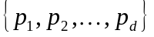
S is the set of all scout outcomes after a run 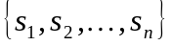
m is the number of possible final configurations of S
A fundamental of scouting is the hope that the MAS is a member of S, since the best member of S will be delivered as the proposed solution.
The number of possible scout outcomes, k, is determined by the branching factor and solution depth of the puzzle.
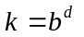
We know n scouts explore n scout paths to generate n scout outcomes. Since each scout discovers one of k final situations, the total number of possible final outcomes for all n scouts is:
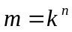
Each duplicated scout path in S is wasted effort; since investigating the same action sequence more than once discovers nothing new. Further, the order of the scout outcomes in S is unimportant, since we do not care which scout generates the acceptable solution.
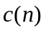 is the coverage after n scout cycles, 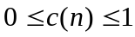
The term “coverage” will be used to describe what fraction of the possible scout outcomes is actually found in S. Ideally, we would like the coverage to be 1, since this represents complete exhaustive search which would guarantee discovery of the MAS.
As a clarifying example, 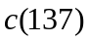 is the percentage of possible scout outcomes that have been generated after 137 scouts have run.
A fundamental question of interest is “What does n need to be to generate good solutions?” The best possible solution will always be found for 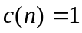, and no solution at all will be found for 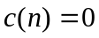. It is easy to see that 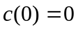 and 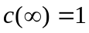, but what should n be to set to some intermediate value?
The first scout always follows one path to one unique outcome, thus:
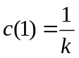
In general, if we let 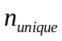 be the number of distinct paths generated by all scouts so far, we have:
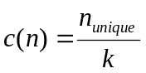
From one run to the next, will vary, since the random choices made by individual scouts will take them down different combinations of paths. However, since n is large, an expression for the average can be developed which should be useful in making accurate predictions.
This expression is built up from the probability of the coverage having each possible value:
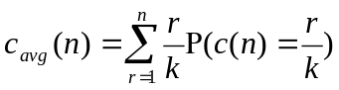
where:
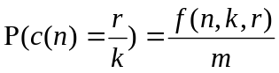
and
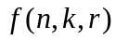 is the number of possible ways for n scouts each of which have k possible routes to investigate exactly r routes combined
In the discussion to follow, the standard notation below for the combinations of a items taken b at a time is used:
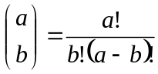
In addition, a notation for the number of permutations of a items taken b at a time without repetition is introduced:
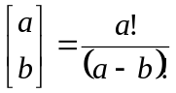
For 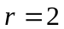, where all of the scouts follow one of 2 paths, it is fairly easy to see by direct tabulation that:
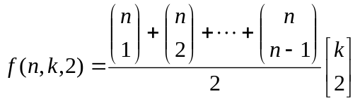
The first part of this expression describes the number of ways to partition n scouts into 2 groups; a split of 1 and n-1, a split of 2 and n-2, and so on. The second part of this expression describes how many permutations of 2 paths there are in a space containing k paths.
In fact, this partitioning of f into two pieces can always be generalized:
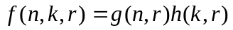
where:
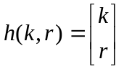
and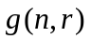has no dependency on k.
Using this new partitioning for f, an improved expression for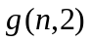can be found:
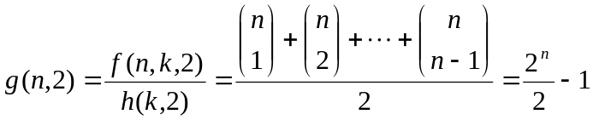
This expression is useful in generalizing the result. It says that, using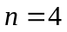as an example, there are seven different ways to partition 4 scouts into 2 groups:
Thus, the average coverage can be re-expressed as:
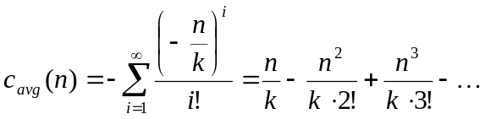
Noting that the Taylor Series expansion of 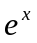is:
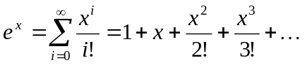
and letting:
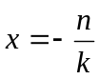
it can be seen that:
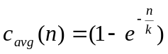
Equation 1
This is a very interesting result. It says that scouting isn’t as haphazard as intuition might suggest. For example, if we run 100,000 scouts on a problem that has 80,000 possible outcomes, the expected average coverage is:
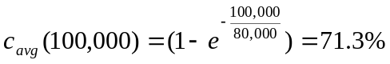
In practice, since we’re running 100,000 scouts, the average behavior will almost always be nearly exactly achieved!
In a puzzle with average branching factor b and solution depth d, we know that . Inserting this into equation 1 and solving for n, we get:
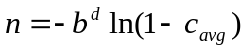
Equation 2
This equation allows estimation of the number of scouts necessary to run before a particular coverage is achieved.
What should be the desired 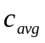? A good estimate can come from specifying a probability of discovery of the MAS. This function is also affected by the expected duplicity of the MAS; that is, how many different solutions would be considered roughly equivalent to the MAS. Then:
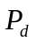 is the probability of discovering an MAS
D is the number of solutions qualifying as an MAS
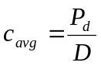
Substituting this into equation 2, we get:
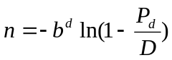
Equation 3
Equation 3 is important enough to warrant an example. Using scouting, the branching factor for an 8-Puzzle is 1.67, and typical solution depth is around 20. If we assume in the worst case that there is only one way to solve the puzzle in 20 moves, and we want a 90% likelihood of finding the solution, we have:
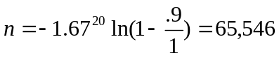
To increase the likelihood of discovering the unique MAS to 99%, n only increases to 131,092. This is still a very small number of scout cycles, given that the circuits execute so rapidly.
The most important variable in equation 3, however, is d. Problems requiring extremely deep solutions are the ones most likely to fail in scouting. In the next section, some other puzzles will be examined, and the limits of scouting will be revealed.

Using Scouting to Solve Other Problems
Armed with the theoretical results of the previous section, we can now look at other problems and develop expressions for the extent of scouting required for solution. Determining the practicality of a scout solution requires some estimate of runtime. In this section, a scout cycle rate of 100 MHz will be assumed (100 million moves/sec). This is approximately accurate for a present CPLD digital logic technology, and future speeds will only get faster.
Using this run rate, a scouting episode requiring n scouts running to a depth d will take:
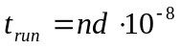
Using this expression, the following puzzle solution runtimes can be developed. This table also includes typical values of n found experimentally. These experimental values are a bit more pessimistic than the theoretical ones, since the only experimental data that can be reported is when the scouting operation actually finds an acceptable solution. This corresponds to 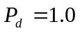, not 0.95.
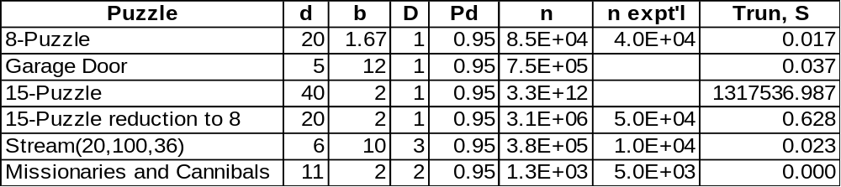
Table 3: Coverage Capability with Various Puzzles
The table introduces some new puzzles, as well as an important result on the 15-Puzzle. These puzzles and ideas will be addressed below.

Stream Crossing
Stream(20,100,36) is the “stream crossing” problem, in which 36 rocks are randomly placed in a 20 unit wide channel across a 100 unit wide stream. Assuming a maximum stride length of 15 units, the goal of the puzzle is to cross the stream (with dry feet) in the minimum number of steps.
The following charts show a sample problem instance and the solution found by scouting. The small dots represent rocks ignored, and the large dots are rocks stepped on. The desired final position is the center of the horizontal grid labeled 100. Since maximum stride is 15 units, the largest step distance between rocks is 1½ grid spacings.
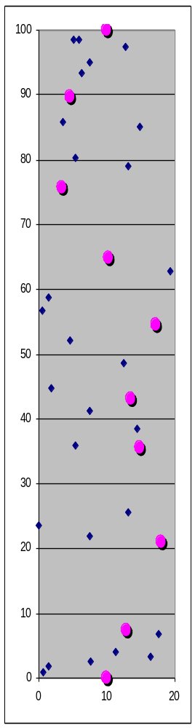
Stream crossing is an interesting problem because it is a real-world problem that humans solve so easily. Look at the chart on the left, and imagine yourself stepping from the bottom to the top. Would you choose the same path that scouting found? How do you choose the path?

Missionaries and Cannibals
This is a time-honored problem involving 3 missionaries and 3 cannibals crossing a river in a canoe that can only hold two people at a time. The must schedule their trips across the river with the caveat that if at any time a group is left alone containing more cannibals than missionaries, something bad (which you can guess) will happen.
This problem is trivial for scouting, which on average finds one of the two optimal solutions in about one thousand scouts.

The 15-Puzzle
The 15-Puzzle at first seems to define the limit of scouting. In fact, though, it helps show how scouting can be applied successfully even to arbitrarily difficult problems.
Because of the increased depth of typical 15-Puzzle solutions, the number of scouts required to cover a reasonable portion of the solution space becomes staggering. In the 15-puzzle, however, it becomes obvious that attempting to plan out a complete strategy before the first move is even made is preposterous.
Instead, we can use the notion of stepped goals, a concept frequently developed in the psychological literature. The 15-Puzzle can be thought of as an extra row and column added to an 8-Puzzle. Consider the 15-Puzzle goal situation below:

9 | 10 | 11 | 12
13 | 1 | 2 | 3
14 | 8 |  | 4
15 | 7 | 6 | 5

One can start by only attempting to place tiles 9-15 first, without regard to what happens in the lower right 3x3 quadrant. Once this is accomplished, a standard 8-Puzzle is all that is left to solve. Since it usually only takes around 20 moves to place tiles 9-15, the problem of reducing a 15-Puzzle to an 8-Puzzle is easily scoutable, and the solution of the final 8-Puzzle has already been shown to be scoutable.
This divide and conquer approach will work for general problems whose branching factor and/or depth make a complete, up-front solution impossible.
This type of approach seems to mimic human reasoning and problem solving strategies quite well.
Once the idea of stepped goals is embraced, further analysis of potential problems seems redundant. For any problem, the following scouting approach may be applied.
- If you know b and d, you can compute the likely solution time on a particular set of processors. If the time is acceptable, perform the solution. If the solution time is excessive, choose an intermediate goal and return to step 1.
- If b and d are unknown, run all scouts available and see if a solution emerges. If no solution emerges, choose an intermediate goal and return to step 2.

Looking Forward
Certain aspects of this dissertation seem a bit regenerative; the more answers you get, the more questions become obvious. Scouting as a general strategy will need to be implemented and applied on many fronts before all of the details become apparent. Several key issues are so tempting to address that they must at least be introduced now. Each of these represents a complete research topic for future study.

How Does Scouting Relate to Associative Memory
Associative memory is the “fruit fly” or “Bohr atom” problem of neural computing. Several ideas seem to offer great promise for using scouting in developing associative memory.
First, the development of an enriched input data set seems like a good idea. Some introductory simulations indicate that while direct sensory input readings from similar items in visual or auditory events may be greatly dissimilar, combinations of these sensory inputs may exhibit more regularity. The combinations can involve sums or differences of particular pairs of inputs, and these “enriched” signals can be produced by an enhanced wavelet-type signal decomposition.
This enriched data stream then contains specific items that can be used to associate memory; that is, by looking at certain data items, and ignoring all others, a classification template can be developed that distinguishes between unrelated events, and correctly groups related ones.
The selection of the subset of enriched data to be examined has been shown to be scoutable for some problems.

Does the Scout Follow Neuroanatomy?
The macrocolumnar architecture of the cortex has been pointed out earlier. A growing body of literature focuses on neocortex anatomy, and some aspects are still controversial. Certainly in the regions of visual processing, motor processing, and the development of strategy and planning, these columns seem to play a major role. The scout design is very appealing in that it could easily be cast into a physical form that was cylindrical, where the output axons of each included neuron were more or less fully connected to the inputs of all of the other neurons in the cylinder.
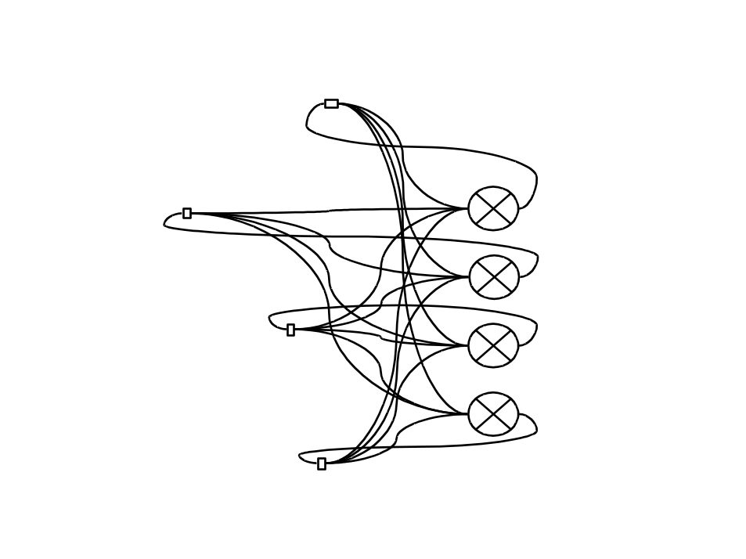
Figure 21: Scout Neural Model
If each neuron’s output can be adjusted through its input weights to be a boolean function of its inputs, then arbitrary scout implementations could be cast a priori as neural networks, with the necessary synapse weights pre-specified by the boolean functions developed in the last section for the digtital implementation.
Unfortunately, the operation of biological neurons isn’t quite flexible enough to implement arbitrary boolean functions. It has been shown, however, that a multilayer, feed-forward arrangement of neurons can be made to implement an arbitrary boolean function. Thus, by adding a few more columns of neurons to the diagram above, we can achieve scout implementation in biological neurons.
An additional question involves what exact mechanism biology might uses for connecting the same scout to different SRG blocks, allowing it to operate on different problems. It seems apparent that, since each neuron has up to 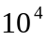 inputs, some very clever gating logic could be used in which control signals determine which neuron inputs are actually “sensitized” at any particular time, effectively decoupling the neuron from all but the SRG blocks of interest.
It is likely that true biological neurons do not have binary outputs, but rather have some multivalued logical output capability. We can ignore this capability, as long as we realize that we will have to use more digital neurons to solve a similar task, simply because the data representation will require more neurons with two-value outputs than would be required for a higher-valued logic.

A Complete Thinking Machine
A complete “thinking machine” is, of course, tempting to contemplate. A good design would require the ability to issue multiple simultaneous searches. That is, it should be able to be able to walk and chew gum at the same time, or at least listen and prepare a response at the same time. This can be handled by partitioning of the processing blocks into groups, and sizing the groups based on the priority of the present tasks. With this design in mind, one can advance an overall model of a thinking machine that looks like the diagram below. In this diagram, PM stands for Procedural Memory, or memory that is inherent and built into task-oriented processing centers (like the ability to ride a bike).
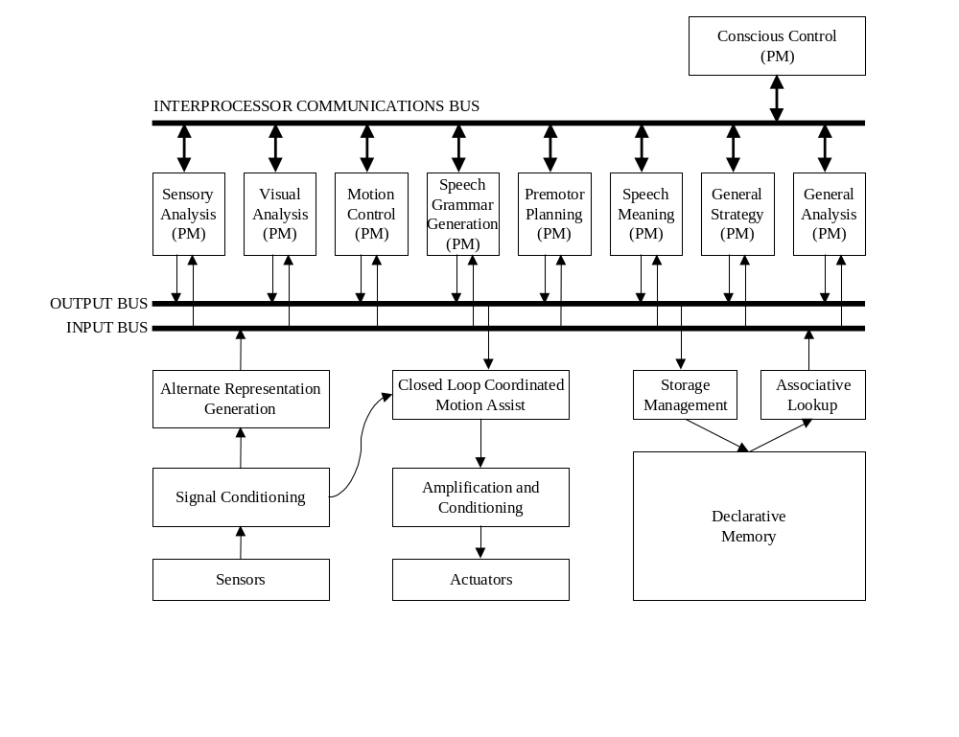
Figure 22: Comprehensive Brain Processing Model
Implementation of such a design is within reach, especially using electronically programmable CPLDs. This reprogrammable ASIC technology would allow reprogramming of the scouts on the fly, permitting dynamic load balancing across system functions, while eliminating the requirement for huge neural fan-in. In this sense, the thinking machine would actually have completely uniform scout macrocells, and the cells could be redistributed to different functions based on some overall master control program, which the diagram labels as “conscious control.”

Duplicate the Brain, or Surpass It?
Most people can’t look at an 8-Puzzle and list the 21 moves, say, required to solve it without physically moving the pieces through each step and then writing them down.
This may be because the brain is essentially memoryless, at least in terms of fast short-term storage. The brain can only iterate so many levels from the actual situation (which is continuously re-input, usually from virtual sensory memory in the optical pathways in most games).
If humans had adequate temporary situation storage, we would feel that Chess was as trivial as tic-tac toe, and every game between two reasonably intelligent players would result in stalemate.
A scout does not have to be limited by lack of temporary, intermediate state storage.
The ability to combine high-speed digital processing technology with high-density digital memory should allow the construction of a machine significantly “smarter” than any human mind. The main challenges will be connection of enough sensory input to give the system a rich enough input stream for it to be able to demonstrate such intelligence.

Implementing Learning
Learning is important in humans in three major areas:
- Learning more raw information (declarative information)
- Learning how to do things (procedural information)
- Remembering the past (so we can choose to repeat it or not) (episodic information)
Some interesting insight into learning comes from the study of “experts.” Humans can become expert at specific tasks through practice and repetition. Expert chess players, for example, can remember actual chess game board situations much better than non-experts. They do no better than non-experts at remembering random chess board arrangements, however.
This suggests that an important part of learning is the representation of the problem in an efficient way. Mathematically, we can think of representing vectors in linear algebra as weighted sums of a particular set basis vectors. If a memory consists of n simultaneous inputs, we could represent it as:
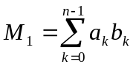
where 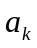are weights, and 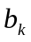 are the n-dimensional basis vectors. If the basis vectors are chosen well, many different memories could be represented efficiently by a fairly small number of non-zero coefficients. The development of many different sets of basis vectors could be directed simply by combining commonly recurring patterns in sensory input, which might correspond to phonemes in auditory recognition, for example.
An additional benefit of this type of memory representation is that associativity is a natural consequence. By finding the memory with the closest set of coefficients to the current situation, we have identified a similar memory, irrespective of the fact that the actual sensory inputs coming from the new situation might be vastly different from those that created the stored memory.
The quality of the associativity, or the “expertness,” of the analysis, is based on the quality and richness of the basis vectors. By imagining a human mind as starting with no basis vectors at birth, and then building up basis vectors based on repeated stimulation patterns, a memory model starts to emerge:
- Early memories are not possible, since basis development is either incomplete, or transitory. Transitory basis vectors would render previously stored coefficients meaningless.
- Childhood stimulation is critical to mental development.
- Learning new information becomes more difficult as one gets older, since more and more complicated basis sets develop, and information which doesn’t fit the old patterns is hard to store.

Learning Procedural Models
At the scouting level, we consider memory only as it relates to remembering the rules and goals of a problem. The actual implementation of the PA, GC, and NS logic developed for our simple games requires quite sophisticated combinational logic that would require many neurons to simulate. It is possible that redundant information in the form of representing the situation in several alternate formats could reduce the complexity of this logic.
Consider that a checkerboard can be represented linearly, in that the pieces could be laid out in a straight line 32 positions long (ignoring the positions in the 8x8 board that never contain a piece). Moves would then be represented by moving the checkers 7 or 9 positions left or right, although there are also rules about watching the linear position mod 8 to make sure you don’t move off the right edge of the board and onto the left. Similarly, jumps would be represented by moves of 14 or 18 spaces left or right, as long as the position half-way between the initial position and the target position is occupied by the enemy. Of course, the same rules of not passing off one side and onto the other must be applied.
Playing checkers in this format would probably be impossible for humans. The human visual cortex develops many alternate representations of vision data which contain different information useful for different purposes. This redundant data could be used to develop different versions of the combinational logic which were smaller or more efficient. In addition, new rules could be added to the rule database. These would be “rules-of-thumb” noticed during problem solving, or noticed during failure, and then added to the given rules of the problem to enhance future solutions.
This second item is obviously of extreme interest. By developing relationships between various data representations, and correlating them with success and failure, it may be possible for a machine to effectively increase its own PA or GC circuitry to improve the quality of its own play. This provides a mechanism for the development of the stepped goals, or intermediate goals, as were found to be important for the 15-Puzzle.
The search for these self-enhancements can be cast as a scouting problem.

Conclusions
The most important conclusion coming from this research is that this initial look at scouting as a hardware engine reveals a technique with broad application in a wide variety of difficult situations. Whether the model is closely aligned with biological processing or not will be shown in years to come. At any rate, however, scouting represents an important processing technique that can almost “magically“ develop solutions to problems that are very difficult to solve.
Of course, there is nothing magical about scouting. In many ways, it is just a technique based on gambling, although with a “stacked” deck. The advantages of scouting in current hardware terms lie in the simplicity of the approach, which allows extremely fast hordes of scouts to virtually guarantee the identification of good solutions to problems very quickly.
The opportunities for further work are enormous, and require additional input from a broad variety of disciplines. The initial results, however, are extremely encouraging.

Appendix A: Wanderer Simulation
This simulation uses the alternative term “spinner” to describe the wanderer.
// Spinner Simulation
// 8 Puzzle Toy Problem

#include <stdio.h>
#include <string.h>
#include <stdlib.h>
#include <time.h>

#define TRUE -1
#define FALSE 0

// 8 Puzzle
// with blank in pos n (0-8), first el is #possible moves,
// remainder are moves
int rndMove8[][5]={
{2,1,3,0,0}, // with blank in pos 0, there are 2 moves, 1 and 3
{3,0,2,4,0}, // with blank in pos 1, there are 3 moves, 0, 2, and 4
{2,1,5,0,0}, // etc.
{3,0,4,6,0},
{4,1,3,5,7},
{3,2,4,8,0},
{2,3,7,0,0},
{3,4,6,8,0},
{2,5,7,0,0}};

// action representation
// int action[2];
// 0= move blank from position...
// 1= to

// Situation representation
// int situation[10];
// position map 0 1 2
// 3 4 5
// 6 7 8
// 9 is redundant location of blank

// the test puzzle
int initialSituation[]={
// 1 8 3
// 0 4 2
// 5 7 6 with blank in pos 3
1,8,3,0,4,2,5,7,6,
3};

// desired goal
int goalSituation[]={
// 1 2 3
// 8 0 4
// 7 6 5 with blank in pos 4
1,2,3,8,0,4,7,6,5,
4};

// display a game situation
void ShowSituation(int* situation)
{
printf(" ---\n");
for(int i=0; i<3; i++)
{
char buf[28];
buf[3]=0;
for(int j=0; j<3; j++)
buf[j]='0'+situation[i*3+j];
printf("|%s|\n",buf);
}
printf(" --%1d\n\n",situation[9]); // shows redundant blank pointer
}

// Is situation in the goal state?
int GoalCheck(int* situation)
{
return 0==memcmp(situation,goalSituation,9*sizeof(int));
}

// Given the current situation, pick a random action
void GenerateRandomAction(int* action,int* situation)
{
// pick a random move using the possible move table
int blankPos=situation[9];
int n=rndMove8[blankPos][0];
int move=rndMove8[blankPos][rand()%n+1];

// build action = from,to
action[0]=blankPos;
action[1]=move;
}

// perform 'action' on 'situation'
void ComputeNewSituation(int* situation, int* action)
{
int from=action[0];
int to=action[1];

situation[from]=situation[to]; // move the blank
situation[to]=0;
situation[9]=to; // update redundant position
}

// Spinner Implementation
// return depth of found solution or -1 if no solution found
int Spinner(int* initialSituation,int maxIterations)
{
int situation[10];
memcpy(situation,initialSituation,10*sizeof(int));

int action[2];
action[0]=-1; // invalid initial action to be ignored

int iterations=0;

while(!GoalCheck(situation) && iterations<maxIterations)
{
GenerateRandomAction(action,situation);
ComputeNewSituation(situation,action);
iterations++;
}

if(iterations<maxIterations)
return iterations;
else
return -1;
}

int main()
{
ShowSituation(initialSituation);

int best=100;

// run 100000 spinners
srand(time(NULL));
for(int i=0; i<100000; i++)
{
int d=Spinner(initialSituation,best);
if(d>0 && d<best)
{
printf("Found solution spinner %d, depth=%d\n",
i,d);
best=d;
}
}

return 0;
}

Appendix B: Scout Simulation
// Given the current situation, pick a random action
// This is the scouting version, which avoids direct backtracks
// This corresponds to FIFO depth=1
void GenerateRandomAction(int* action,int* situation)
{
int blankPos=situation[9];
int lastBlankPos=action[0];

// keep picking random moves until we aren't backtracking
int move=lastBlankPos;
while(move==lastBlankPos)
{
int n=rndMove8[blankPos][0];
move=rndMove8[blankPos][rand()%n+1];
}

// build action = from,to
action[0]=blankPos;
action[1]=move;
}

Bibliography
Much of the anatomical and physiological information in this dissertation comes from Gray’s Anatomy, 38th Edition (1995), published by Churchill Livingstone, and edited by Bannister, Berry, Collins, Dussek, Dyson, Ellis, Gabella, Salmons, Soames, and Standring. This is really THE authority and state-of-knowledge on human anatomy.
Other References:
Allport, Susan (1986). Explorers of the Black Box. W.W. Norton & Co.
Bardell, Paul, William H. McAnney, and Jacob Savir (1987). Built-In Test for VLSI: Pseudorandom Techniques. John Wiley and Sons.
Cairns-Smith, A. G. (1996). Evolving the Mind. Cambridge University Press.
Caudill, Maureen and Charles Butler (1990). Naturally Intelligent Systems. MIT Press.
Chen, C. H. (Ed) (1996). Fuzzy Logic and Neural Network Handbook. McGraw-Hill.
Cherkassky, Vladimir and Filip Mulier (1998). Learning from Data. John Wiley and Sons.
De Becker, Gavin (1997). The Gift of Fear. Little, Brown, and Co.
Epp, Susanna S. (1995). Discrete Mathematics with Applications. Brooks/Cole Publishing.
Greenfield, Susan A. (1997). The Human Brain. Harper Collins.
Hertz, John, Anders Krogh, and Richard G. Palmer (1991). Introduction to the Theory of Neural Computation. Addison-Wesley.
Hill, Frederick J, and Gerald R. Peterson (1978). Digital Systems: Hardware Organization and Design. John Wiley and Sons.
Khanna, Tarun (1990). Foundations of Neural Networks. Addison-Wesley.
LLins, Rodolfo R (Ed.) (1988). The Biology of the Brain. Readings from Scientific American. W.H. Freeman and Co.
Matlin, Margaret W. (1998). Cognition, 4th Edition. Harcourt Brace.
Polivka, Raymond P. and Sandra Pakin (1975). APL: The Language and Its Usage. Prentice-Hall.
Press, William H., Saul A. Teukolsky, William T. Vetterling, and Brian P. Flannery (1992). Numerical Recipes in C: The Art of Scientific Computing. Cambridge University Press.
Rietman, Ed (1988). Experiments in Artificial Neural Networks. Tab Books.
Russell, Stuart and Peter Norvig (1995). Artificial Intelligence. Prentice Hall.
Stark, Henry and John Woods (1986). Probability, Random Processes, and Estimation Theory for Engineers. Prentice-Hall.
Sedgewick, Robert (1990). Algorithms in C. Addison-Wesley.
Squire, Larry R. (1987). Memory and Brain. Oxford University Press.
Welstead, Stephen T. (1994). Neural Network and Fuzzy Logic Applications in C/C++. John Wiley and Sons.

Polivka (1975), p. 90
Sedgewick (1990), p. 4
Sedgewick (1990), p. 529
Sedgewick (1990), p. 634
Sedgewick (1990), p. 635
Sedgewick (1990), p. 639
As quoted by Allport (1986), p. 47
Baars, B.J. A Cognitive Theory of Consciousness, quoted by Cairns-Smith (1996), p. 99
Cairns-Smith (1996), p. 113
Several articles in Scientific American, 1987 – 1992, cited by Cairns-Smith (1996).
Allport (1986), p. 57
Allport (1986), p. 164
As quoted by Allport (1986), p. 168
Paraphrase of Allport (1986), p. 169
Cairns-Smith (1996), p. 55
R. Wrangham and D. Peterson, Demonic Males, as quoted by DeBecker (1997), p.43
Humans have been engaged (sporadically) in intellectual pursuits since around the time the ancient Sumerians began trading in their farming villages, ca. 5000 BC. Human evolution didn’t really start until the mammalian explosion post-dinosauria, 65 million years ago. Thus, we’ve only gotten intellectual in the last 0.01% of our developmental history.
As noted by Cairns-Smith (1996), p. 122
When looking at such figures, one always has to wonder at the power of olfactory processing as a replacement for intelligence. Lower animals are such tremendously effective predators as a result of more highly developed olfactory capacity. In humans, olfactory capacity is almost non-existent, however, we are the most effective, deadly, and successful predators of all time.
Greenfield (1997), p. 14-15
Squire (1987), p. 70
For now, suffice it to say that the complexity of the hardware, and its corresponding execution speed, is enormously dependent on how the data is represented. Learning new ways to represent the data may be the most critical element of all in developing an expert rating in a particular task.
The author has not verified that 21 is the optimal solution, but hundreds of runs have found no better solution. While each simulation runs in only a second or two on my 333 MHz Pentium-II class machine, a directed A* search algorithm crafted in LISP seems to wallow interminably on the same machine.
Hertz (1991), p. 11
Norvig (1995), p. 583
Matlin (1998), p. 364 cites the work of DeGroot (1966), Simon & Chase (1973), Vincente & DeGroot (1990)

